**My CleanZone**

**(Android Studio Project)**

By:

Arshdeep Singh

**PURPOSE**

Mobile app based on Laundry and Dry cleaning Services.

Doing the laundry can take a lots of time out of your day. I’s hard enough to do laundry at home while trying to get other chores done.

Washing machines of high capacity have been developed and steam pressing and calendaring machines have also come up to make wrinkle free and press automatically but they are too costly to afford.

In conventional washing, water is the main medium and detergent or soap is used for washing. In such case, costly clothes may shrink or colour may fade in the presence of strong alkalis.

Dry cleaning need lot of care and systematic procedure and chemicals, it is not easy to carry out at home and service units are found in major towns for this activity

[***My CleanZone App***](https://codeshoppy.com/shop/product/laundry-service-app/) helps taking care of your costly,valuable clothes. Customer can select the category (Wash&Iron , Iron ,Dry clean) and place the order by entering the quantity and pay accordingly. The company service man collects your clothes from your place and also delivers them back by the date provided on the app.

**Main Activity (First Screen)**

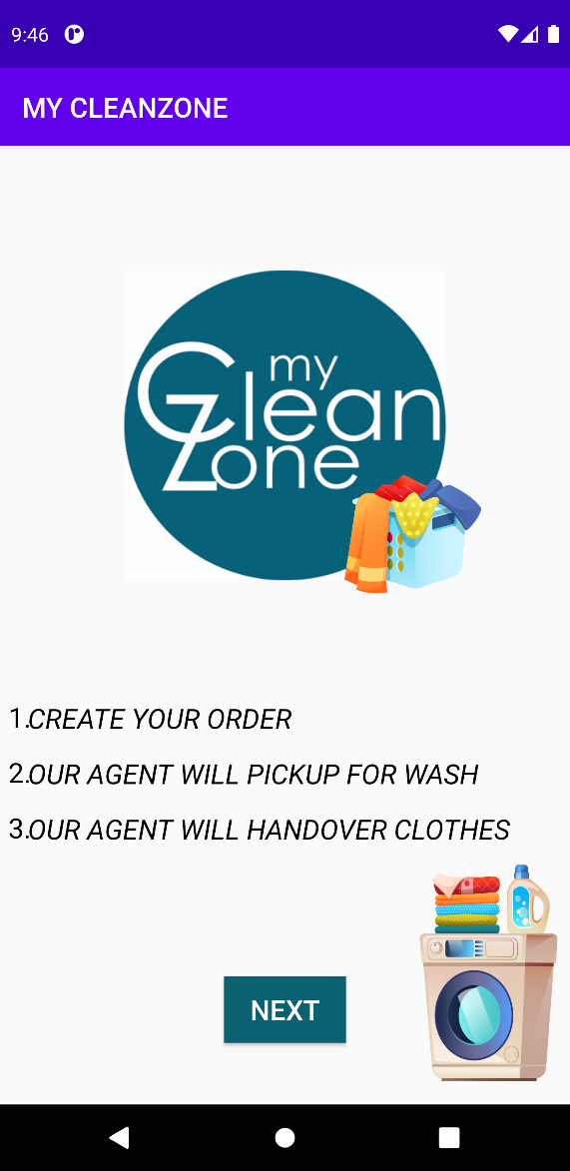

Main Activity.xml

*<?***xml version="1.0" encoding="utf-8"***?>*<**android.support.constraint.ConstraintLayout xmlns:android="http://schemas.android.com/apk/res/android"  
 xmlns:app="http://schemas.android.com/apk/res-auto"  
 xmlns:tools="http://schemas.android.com/tools"  
 android:layout_width="match_parent"  
 android:layout_height="match_parent"  
 tools:context=".MainActivity1"**>  
  
 <**TextView  
 android:layout_width="232dp"  
 android:layout_height="224dp"  
 android:background="@drawable/logo"  
 tools:layout_editor_absoluteX="101dp"  
 android:gravity="center"  
 android:id="@+id/logo"  
 app:layout_constraintStart_toStartOf="parent"  
 app:layout_constraintEnd_toEndOf="parent"  
 app:layout_constraintTop_toTopOf="parent"  
 android:layout_marginTop="90dp"  
 tools:layout_editor_absoluteY="96dp"** />  
  
 <**TextView  
 android:layout_width="198dp"  
 android:layout_height="130dp"  
 android:layout_marginStart="188dp"  
  
 android:background="@drawable/wash2"  
 app:layout_constraintTop_toTopOf="parent"  
 android:layout_marginTop="210dp"  
 app:layout_constraintStart_toStartOf="parent"** />  
  
 <**Button  
 android:id="@+id/button3"  
 android:layout_width="wrap_content"  
 android:layout_height="wrap_content"  
 android:background="@color/midnight_blue"  
 android:text="NEXT"  
 android:textColor="@color/white"  
 android:textSize="20dp"  
 tools:layout_editor_absoluteX="173dp"  
 tools:layout_editor_absoluteY="624dp"  
 app:layout_constraintStart_toStartOf="parent"  
 app:layout_constraintTop_toTopOf="parent"  
 android:layout_marginTop="600dp"  
 app:layout_constraintEnd_toEndOf="parent"**/>  
 <**TextView  
 android:layout_width="wrap_content"  
 android:layout_height="wrap_content"  
 android:text="1."  
 android:layout_marginTop="399dp"  
 android:layout_marginLeft="6dp"  
 app:layout_constraintStart_toStartOf="parent"  
 android:textSize="20dp"  
 android:textColor="@color/black"  
 app:layout_constraintTop_toTopOf="parent"**/>  
 <**TextView  
 android:layout_width="wrap_content"  
 android:layout_height="wrap_content"  
 android:text="2."  
 android:layout_marginTop="439dp"  
 android:layout_marginLeft="6dp"  
 app:layout_constraintStart_toStartOf="parent"  
 android:textSize="20dp"  
 android:textColor="@color/black"  
 app:layout_constraintTop_toTopOf="parent"**/>  
 <**TextView  
 android:layout_width="wrap_content"  
 android:layout_height="wrap_content"  
 android:text="3."  
 android:layout_marginTop="479dp"  
 android:layout_marginLeft="6dp"  
 app:layout_constraintStart_toStartOf="parent"  
 android:textSize="20dp"  
 android:textColor="@color/black"  
 app:layout_constraintTop_toTopOf="parent"**/>  
 <**TextView  
 android:id="@+id/textView11"  
 android:layout_width="336dp"  
 android:layout_height="33dp"  
 android:layout_marginLeft="20dp"  
  
  
 android:layout_marginTop="400dp"  
 android:fontFamily="@font/happy_monkey"  
 android:text="CREATE YOUR ORDER"  
 android:textColor="@color/black"  
 android:textSize="20dp"  
 android:textStyle="italic"  
 app:layout_constraintStart_toStartOf="parent"  
  
 app:layout_constraintTop_toTopOf="parent"** />  
  
 <**TextView  
 android:id="@+id/textView12"  
 android:layout_width="435dp"  
 android:layout_height="34dp"  
 android:layout_marginLeft="20dp"  
 android:layout_marginTop="440dp"  
 android:fontFamily="@font/happy_monkey"  
 android:text="OUR AGENT WILL PICKUP FOR WASH"  
 android:textColor="@color/black"  
 android:textSize="20dp"  
  
 android:textStyle="italic"  
 app:layout_constraintStart_toStartOf="parent"  
 app:layout_constraintTop_toTopOf="parent"** />  
  
 <**TextView  
 android:id="@+id/textView15"  
 android:layout_width="422dp"  
 android:layout_height="31dp"  
 android:layout_marginLeft="20dp"  
 android:layout_marginTop="480dp"  
 android:fontFamily="@font/happy_monkey"  
 android:text="OUR AGENT WILL HANDOVER CLOTHES"  
  
 android:textColor="@color/black"  
 android:textSize="20dp"  
 android:textStyle="italic"  
 app:layout_constraintStart_toStartOf="parent"  
 app:layout_constraintTop_toTopOf="parent"** />  
  
 <**TextView  
 android:layout_width="294dp"  
 android:layout_height="190dp"  
 android:layout_marginLeft="200dp"  
 android:background="@drawable/washi"  
 app:layout_constraintBottom_toBottomOf="parent"  
 app:layout_constraintStart_toStartOf="parent"** />  
  
</**android.support.constraint.ConstraintLayout**>

Main Activity.java

**package** com.example.mycleanzone;  
  
 **import** android.content.Intent;  
 **import** android.support.v7.app.AppCompatActivity;  
 **import** android.os.Bundle;  
 **import** android.view.View;  
 **import** android.widget.Button;  
  
**public class** MainActivity **extends** AppCompatActivity {  
Button **next**;  
 @Override  
 **protected void** onCreate(Bundle savedInstanceState) {  
 **super**.onCreate(savedInstanceState);  
 setContentView(R.layout.***activity_main***);  
 **next**=(Button)findViewById(R.id.***button3***);  
  
 **next**.setOnClickListener(**new** View.OnClickListener() {  
 @Override  
 **public void** onClick(View v) {  
 Intent it=**new** Intent(getApplicationContext(),MainActivity1.**class**);  
 startActivity(it);  
 }  
 });  
 }  
}

**Main Activity 1 (LOGIN):**

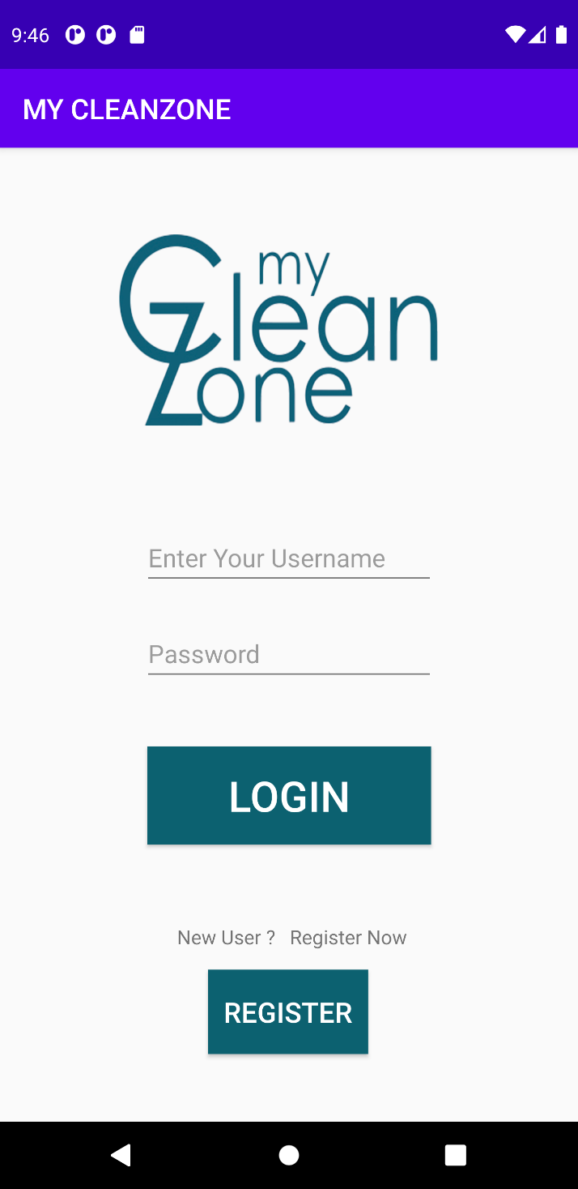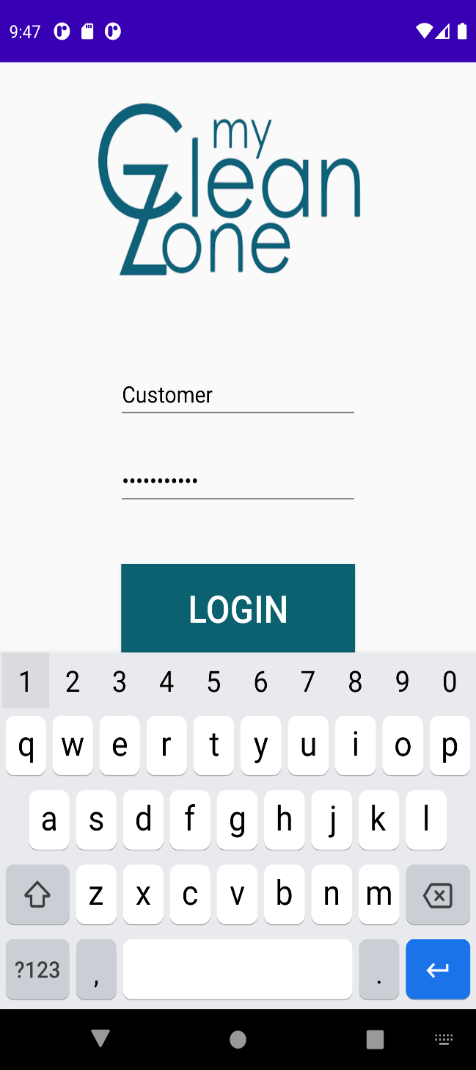

Main Activity1.xml

*<?***xml version="1.0" encoding="utf-8"***?>*<**android.support.constraint.ConstraintLayout xmlns:android="http://schemas.android.com/apk/res/android"  
 xmlns:app="http://schemas.android.com/apk/res-auto"  
 xmlns:tools="http://schemas.android.com/tools"  
 android:layout_width="match_parent"  
 android:layout_height="match_parent"  
 tools:context=".MainActivity1"**>  
  
 <**TextView  
 android:id="@+id/textView23"  
 android:layout_width="379dp"  
 android:layout_height="251dp"  
 android:layout_marginBottom="10dp"  
 android:background="@drawable/logo3"  
 app:layout_constraintBottom_toTopOf="@+id/Name"  
 app:layout_constraintStart_toStartOf="parent"  
 app:layout_constraintTop_toTopOf="parent"** />  
  
 <**EditText  
 android:id="@+id/Name"  
 android:layout_width="wrap_content"  
 android:layout_height="wrap_content"  
 android:layout_marginBottom="19dp"  
 android:ems="10"  
 android:hint="Enter Your Username"  
 android:inputType="textPersonName"  
 android:textColor="@color/black"  
 app:layout_constraintBottom_toTopOf="@+id/Password"  
 app:layout_constraintEnd_toEndOf="parent"  
 app:layout_constraintStart_toStartOf="parent"  
 app:layout_constraintTop_toBottomOf="@+id/textView23"** />  
  
 <**EditText  
 android:id="@+id/Password"  
 android:layout_width="wrap_content"  
 android:layout_height="wrap_content"  
  
 android:layout_marginBottom="39dp"  
 android:ems="10"  
 android:hint="Password"  
 android:inputType="textPassword"  
 android:textColor="@color/black"  
 app:layout_constraintBottom_toTopOf="@+id/login"  
 app:layout_constraintStart_toStartOf="@+id/Name"  
 app:layout_constraintTop_toBottomOf="@+id/Name"** />  
  
 <**Button  
 android:id="@+id/login"  
 android:layout_width="202dp"  
 android:layout_height="70dp"  
 android:layout_marginBottom="52dp"  
 android:background="@color/midnight_blue"  
 android:text="LOGIN"  
  
 android:textColor="@color/white"  
 android:textSize="30dp"  
 app:layout_constraintBottom_toTopOf="@+id/textView8"  
 app:layout_constraintEnd_toEndOf="parent"  
 app:layout_constraintStart_toStartOf="parent"  
 app:layout_constraintTop_toBottomOf="@+id/Password"** />  
  
 <**TextView  
 android:id="@+id/textView8"  
 android:layout_width="wrap_content"  
 android:layout_height="wrap_content"  
 android:layout_marginStart="21dp"  
 android:layout_marginBottom="10dp"  
 android:text="New User ? Register Now"  
 app:layout_constraintBottom_toTopOf="@+id/register"  
 app:layout_constraintStart_toStartOf="@+id/login"  
 app:layout_constraintTop_toBottomOf="@+id/login"** />  
  
 <**Button  
 android:id="@+id/register"  
 android:layout_width="114dp"  
 android:layout_height="60dp"  
 android:layout_marginBottom="44dp"  
 android:background="@color/midnight_blue"  
 android:text="Register"  
 android:textColor="@color/white"  
 android:textSize="20dp"  
 app:layout_constraintBottom_toBottomOf="parent"  
 app:layout_constraintEnd_toEndOf="parent"  
 app:layout_constraintHorizontal_bias="0.498"  
 app:layout_constraintStart_toStartOf="parent"  
 app:layout_constraintTop_toBottomOf="@+id/textView8"** />  
</**android.support.constraint.ConstraintLayout**>

MainActivity1.java

**package** com.example.mycleanzone;  
  
**import** android.content.Intent;  
**import** android.support.v7.app.AppCompatActivity;  
**import** android.os.Bundle;  
**import** android.view.View;  
**import** android.widget.Button;  
**import** android.widget.EditText;  
**import** android.widget.Toast;  
  
**public class** MainActivity1 **extends** AppCompatActivity {  
 EditText **usr**,**pass**;  
 Button **login**,**register**;  
 @Override  
 **protected void** onCreate(Bundle savedInstanceState) {  
 **super**.onCreate(savedInstanceState);  
 setContentView(R.layout.***activity_main1***);  
 **usr**=(EditText)findViewById(R.id.***Name***);  
 **pass**=(EditText)findViewById(R.id.***Password***);  
 **login**=(Button)findViewById(R.id.***login***);  
 **register**=(Button)findViewById(R.id.***register***);  
 **login**.setOnClickListener(**new** View.OnClickListener() {  
 @Override  
 **public void** onClick(View v) {  
 String user=**usr**.getText().toString();  
 String pasw=**pass**.getText().toString();  
 **if**(user.equals(**"Customer"**) && pasw.equals(**"123customer"**)){  
 Intent intent=**new** Intent(getApplicationContext(),Category.**class**);  
 intent.putExtra(**"usr"**,user);  
 startActivity(intent);  
 }  
 **else** Toast.*makeText*(getApplicationContext(),**"INCORRECT USERNAME OR PASSWORD"**,Toast.***LENGTH_LONG***).show();  
 }  
 }  
 );  
 **register**.setOnClickListener(**new** View.OnClickListener(){  
 @Override  
 **public void** onClick(View v){  
  
 Intent it=**new** Intent(getApplicationContext(),Register.**class**);  
  
 startActivity(it);  
 }  
 });  
 }  
}

**Register screen:**

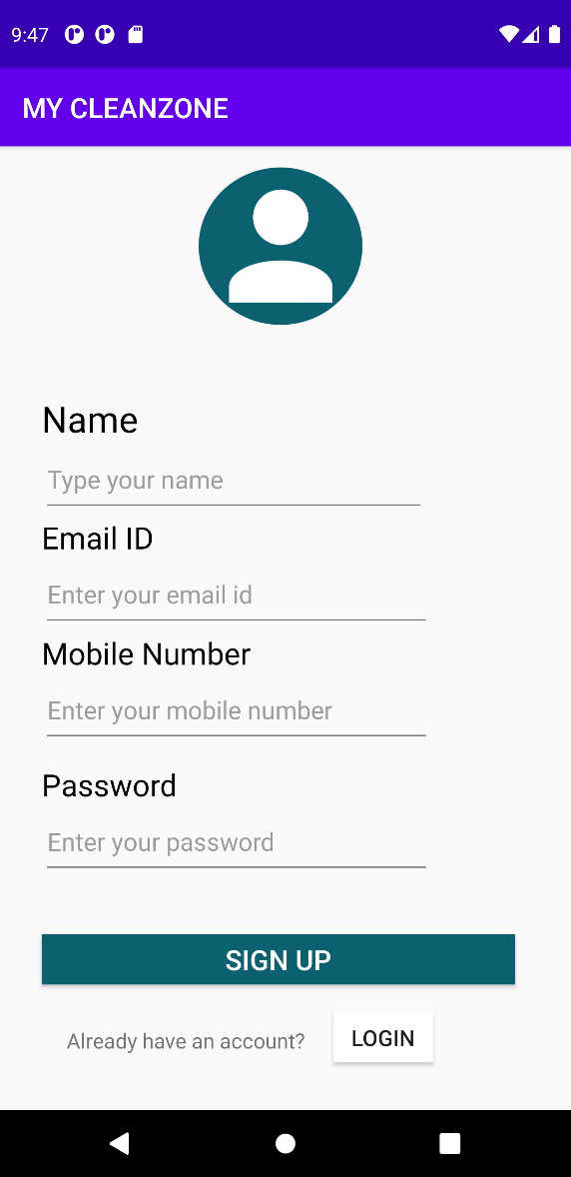

Register.xml

*<?***xml version="1.0" encoding="utf-8"***?>*<**android.support.constraint.ConstraintLayout xmlns:android="http://schemas.android.com/apk/res/android"  
 xmlns:app="http://schemas.android.com/apk/res-auto"  
 xmlns:tools="http://schemas.android.com/tools"  
 android:layout_width="match_parent"  
 android:layout_height="match_parent"  
 tools:context=".Register"**>  
  
 <**TextView  
 android:id="@+id/textView20"  
 android:layout_width="118dp"  
 android:layout_height="113dp"  
 app:layout_constraintStart_toStartOf="parent"  
 android:layout_marginLeft="143dp"  
 app:layout_constraintTop_toTopOf="parent"  
 android:layout_marginTop="15dp"  
 android:background="@drawable/login"  
 tools:layout_editor_absoluteX="138dp"  
 tools:layout_editor_absoluteY="16dp"** />  
  
 <**TextView  
 android:id="@+id/name"  
 android:layout_width="wrap_content"  
 android:layout_height="wrap_content"  
 android:text="Name"  
  
 android:textColor="@color/black"  
 android:textSize="26dp"  
 app:layout_constraintBottom_toTopOf="@id/editTextTextPersonName"  
 app:layout_constraintStart_toStartOf="@id/editTextTextPersonName"  
 app:layout_constraintTop_toBottomOf="@+id/login"  
 tools:layout_editor_absoluteX="40dp"  
 tools:layout_editor_absoluteY="149dp"** />  
  
 <**EditText  
 android:id="@+id/editTextMobileNumber"  
 android:layout_width="281dp"  
 android:layout_height="53dp"  
 android:layout_marginBottom="12dp"  
 android:ems="10"  
 android:hint="Enter your mobile number"  
 android:inputType="phone"  
 app:layout_constraintBottom_toTopOf="@id/textView13"  
 app:layout_constraintStart_toStartOf="parent"  
 android:layout_marginLeft="30dp"  
 tools:layout_editor_absoluteX="40dp"  
 tools:layout_editor_absoluteY="384dp"** />  
  
 <**EditText  
 android:id="@+id/editTextTextPersonName"  
  
 android:layout_width="277dp"  
 android:layout_height="53dp"  
 android:layout_marginLeft="30dp"  
 android:ems="10"  
 android:hint="Type your name"  
 android:inputType="textPersonName"  
 app:layout_constraintBottom_toTopOf="@+id/emailId"  
 app:layout_constraintStart_toStartOf="parent"  
  
 tools:layout_editor_absoluteX="40dp"  
 tools:layout_editor_absoluteY="184dp"** />  
  
 <**EditText  
 android:id="@+id/editTextTextPersonName2"  
 android:layout_width="281dp"  
 android:layout_height="53dp"  
 android:layout_marginBottom="30dp"  
 android:ems="10"  
 android:hint="Enter your email id"  
 android:inputType="textPersonName"  
 app:layout_constraintBottom_toTopOf="@id/editTextMobileNumber"  
 app:layout_constraintStart_toStartOf="@id/editTextTextPersonName"  
 tools:layout_editor_absoluteX="40dp"  
 tools:layout_editor_absoluteY="284dp"** />  
  
 <**TextView  
 android:id="@+id/emailId"  
 android:layout_width="wrap_content"  
 android:layout_height="wrap_content"  
 android:text="Email ID"  
 android:textColor="@color/black"  
 android:textSize="22dp"  
 app:layout_constraintBottom_toTopOf="@id/editTextTextPersonName2"  
 app:layout_constraintStart_toStartOf="@id/editTextTextPersonName"  
 tools:layout_editor_absoluteX="40dp"  
 tools:layout_editor_absoluteY="254dp"** />  
  
 <**TextView  
 android:id="@+id/mobile"  
 android:layout_width="wrap_content"  
 android:layout_height="wrap_content"  
 android:text="Mobile Number"  
 android:textColor="@color/black"  
 android:textSize="22dp"  
 app:layout_constraintBottom_toTopOf="@id/editTextMobileNumber"  
 app:layout_constraintStart_toStartOf="@id/editTextTextPersonName2"  
 tools:layout_editor_absoluteX="40dp"  
 tools:layout_editor_absoluteY="354dp"** />  
  
 <**TextView  
 android:id="@+id/textView13"  
 android:layout_width="wrap_content"  
 android:layout_height="wrap_content"  
 android:text="Password"  
 android:textColor="@color/black"  
 android:textSize="22dp"  
 app:layout_constraintBottom_toTopOf="@id/editTextTextPassword"  
 app:layout_constraintStart_toStartOf="@id/editTextMobileNumber"  
 tools:layout_editor_absoluteX="40dp"  
 tools:layout_editor_absoluteY="458dp"** />  
  
 <**EditText  
 android:id="@+id/editTextTextPassword"  
 android:layout_width="281dp"  
 android:layout_height="53dp"  
 android:layout_marginBottom="40dp"  
 android:ems="10"  
 android:layout_marginLeft="30dp"  
 android:hint="Enter your password"  
 android:inputType="textPassword"  
 app:layout_constraintBottom_toTopOf="@+id/button2"  
 app:layout_constraintStart_toStartOf="parent"  
 tools:layout_editor_absoluteX="40dp"  
 tools:layout_editor_absoluteY="488dp"** />  
  
 <**Button  
 android:id="@+id/button2"  
 android:layout_width="341dp"  
 android:layout_height="36dp"  
 android:layout_marginBottom="30dp"  
 android:background="@color/midnight_blue"  
 android:text="Sign Up"  
 android:textColor="@color/white"  
 android:textSize="20dp"  
 app:layout_constraintBottom_toTopOf="@+id/textView14"  
 app:layout_constraintStart_toStartOf="parent"  
 android:layout_marginLeft="30dp"  
 tools:layout_editor_absoluteX="35dp"  
 tools:layout_editor_absoluteY="569dp"** />  
  
 <**TextView  
 android:id="@+id/textView14"  
 android:layout_width="wrap_content"  
 android:layout_height="wrap_content"  
 android:layout_marginTop="10dp"  
 android:text="Already have an account?"  
 android:textSize="15dp"  
 app:layout_constraintStart_toStartOf="parent"  
 app:layout_constraintBottom_toBottomOf="parent"  
 android:layout_marginBottom="40dp"  
 android:layout_marginLeft="48dp"  
 tools:layout_editor_absoluteX="67dp"  
 tools:layout_editor_absoluteY="651dp"** />  
  
 <**Button  
 android:id="@+id/log_in"  
 android:layout_width="72dp"  
 android:layout_height="36dp"  
 android:layout_marginTop="20dp"  
 android:background="@color/white"  
 android:text="Login"  
 android:textSize="16dp"  
 app:layout_constraintStart_toStartOf="parent"  
 android:layout_marginLeft="240dp"  
 app:layout_constraintTop_toBottomOf="@id/button2"  
 tools:layout_editor_absoluteX="235dp"  
 tools:layout_editor_absoluteY="644dp"** />  
  
</**android.support.constraint.ConstraintLayout**>

Register.java

**package** com.example.mycleanzone;  
  
**import** android.content.Intent;  
**import** android.support.v7.app.AppCompatActivity;  
**import** android.os.Bundle;  
**import** android.view.View;  
**import** android.widget.Button;  
  
**public class** Register **extends** AppCompatActivity {  
 Button **bt**;  
  
 @Override  
 **protected void** onCreate(Bundle savedInstanceState) {  
 **super**.onCreate(savedInstanceState);  
 setContentView(R.layout.***activity_register***);  
 **bt** = (Button) findViewById(R.id.***button2***);  
 **bt**.setOnClickListener(**new** View.OnClickListener() {  
 @Override  
 **public void** onClick(View v) {  
  
 Intent it = **new** Intent(getApplicationContext(), MainActivity.**class**);  
 startActivity(it);  
 }  
  
 ;  
 });  
 }  
}

**Category screen :**

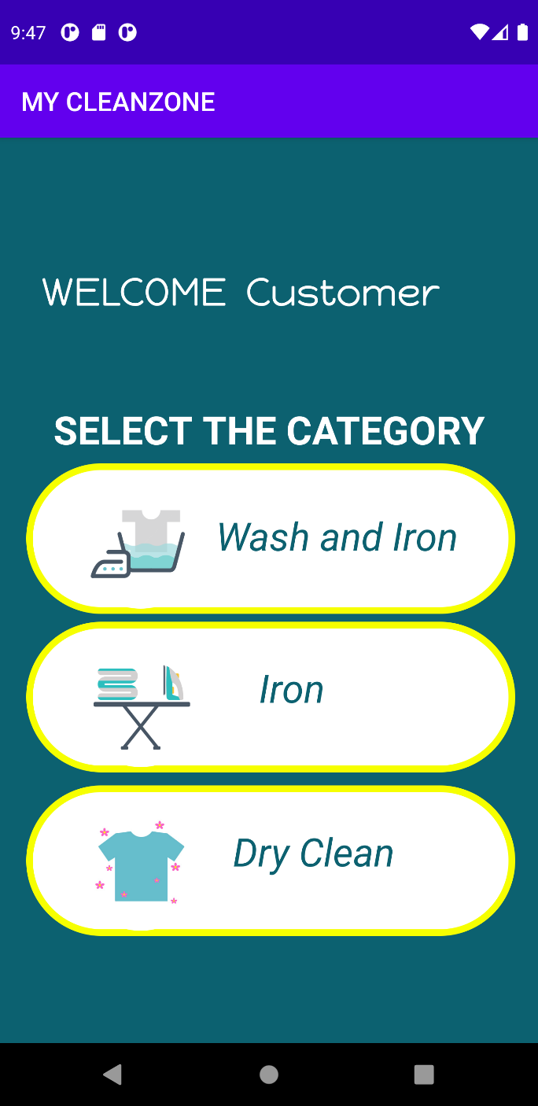

Category.xml

*<?***xml version="1.0" encoding="utf-8"***?>*<**android.support.constraint.ConstraintLayout xmlns:android="http://schemas.android.com/apk/res/android"  
 xmlns:app="http://schemas.android.com/apk/res-auto"  
 xmlns:tools="http://schemas.android.com/tools"  
 android:layout_width="match_parent"  
 android:layout_height="match_parent"  
 android:background="@color/midnight_blue"  
 tools:context=".Category"**>  
  
  
 <**Button  
 android:id="@+id/was_ir"  
 android:layout_width="99dp"  
 android:layout_height="99dp"  
 android:background="@drawable/wash"  
 app:layout_constraintStart_toStartOf="parent"  
 android:layout_marginLeft="58dp"  
 app:layout_constraintTop_toTopOf="@id/oval1"  
  
 android:layout_marginTop="12dp"  
 tools:layout_editor_absoluteX="58dp"  
 tools:layout_editor_absoluteY="262dp"** />  
  
  
 <**TextView  
 android:layout_width="374dp"  
 android:layout_height="115dp"  
 android:layout_marginStart="20dp"  
 android:background="@drawable/circle_shape"  
 android:id="@+id/oval1"  
 app:layout_constraintStart_toStartOf="parent"  
 app:layout_constraintBottom_toTopOf="@id/iron"  
 android:layout_marginBottom="30dp"  
 app:layout_constraintTop_toBottomOf="@id/textView10"  
 android:layout_marginTop="18dp"  
 tools:layout_editor_absoluteY="258dp"** />  
  
 <**TextView  
 android:id="@+id/wash_txt"  
 android:layout_width="216dp"  
 android:layout_height="47dp"  
 android:layout_marginLeft="80dp"  
  
 app:layout_constraintTop_toTopOf="@id/oval1"  
  
 android:layout_marginTop="30dp"  
 app:layout_constraintStart_toStartOf="@+id/was_ir"  
 android:paddingLeft="27dp"  
 android:paddingTop="5dp"  
 android:background="@color/white"  
 android:text="Wash and Iron"  
 android:textColor="@color/midnight_blue"  
 android:textSize="30dp"  
 android:textStyle="italic"  
 tools:layout_editor_absoluteX="139dp"  
 tools:layout_editor_absoluteY="291dp"** />  
 <**TextView  
 android:layout_width="374dp"  
 android:layout_height="115dp"  
 android:layout_marginStart="20dp"  
 android:background="@drawable/circle_shape"  
 app:layout_constraintStart_toStartOf="parent"  
 app:layout_constraintTop_toBottomOf="@id/was_ir"  
 app:layout_constraintBottom_toTopOf="@id/dry_clean"  
 android:layout_marginBottom="30dp"  
 android:id="@+id/oval2"  
 android:layout_marginTop="18dp"  
 tools:layout_editor_absoluteY="258dp"** />  
  
 <**Button  
 android:id="@+id/iron"  
 android:layout_width="99dp"  
 android:layout_height="99dp"  
 android:background="@drawable/iron"  
 app:layout_constraintStart_toStartOf="parent"  
 android:layout_marginLeft="58dp"  
  
 app:layout_constraintTop_toTopOf="@id/oval2"  
 android:layout_marginTop="12dp"  
 android:layout_marginBottom="20dp"  
 tools:layout_editor_absoluteX="56dp"  
 tools:layout_editor_absoluteY="387dp"** />  
  
 <**TextView  
 android:id="@+id/irontxt"  
 android:layout_width="216dp"  
 android:layout_height="47dp"  
 android:background="@color/white"  
 android:paddingLeft="50dp"  
 android:paddingTop="5dp"  
 android:text="Iron"  
 android:textColor="@color/midnight_blue"  
 android:textSize="30dp"  
 android:layout_marginLeft="90dp"  
  
 app:layout_constraintTop_toTopOf="@id/oval2"  
 android:layout_marginTop="25dp"  
 app:layout_constraintStart_toStartOf="@+id/iron"  
 android:textStyle="italic"  
 tools:layout_editor_absoluteX="139dp"  
 tools:layout_editor_absoluteY="410dp"** />  
 <**TextView  
 android:layout_width="374dp"  
 android:layout_height="115dp"  
 android:layout_marginStart="20dp"  
 android:background="@drawable/circle_shape"  
 app:layout_constraintStart_toStartOf="parent"  
 app:layout_constraintTop_toBottomOf="@id/iron"  
 app:layout_constraintBottom_toBottomOf="parent"  
 android:layout_marginBottom="90dp"  
 android:id="@+id/oval3"  
 android:layout_marginTop="22dp"  
 tools:layout_editor_absoluteY="258dp"** />  
  
  
 <**Button  
 android:id="@+id/dry_clean"  
 android:layout_width="99dp"  
 android:layout_height="99dp"  
 android:background="@drawable/dry_clean"  
 app:layout_constraintTop_toTopOf="@id/oval3"  
 android:layout_marginTop="12dp"  
 tools:layout_editor_absoluteX="56dp"  
 app:layout_constraintStart_toStartOf="parent"  
 android:layout_marginLeft="58dp"  
 tools:layout_editor_absoluteY="510dp"** />  
  
 <**TextView  
 android:id="@+id/drytxt"  
 android:layout_width="216dp"  
 android:layout_height="47dp"  
 android:background="@color/white"  
 android:paddingLeft="30dp"  
 android:paddingTop="5dp"  
 android:text="Dry Clean"  
 android:textColor="@color/midnight_blue"  
 app:layout_constraintTop_toTopOf="@id/oval3"  
 android:layout_marginTop="25dp"  
 app:layout_constraintStart_toStartOf="@+id/dry_clean"  
 android:layout_marginLeft="90dp"  
 android:textSize="30dp"  
 android:textStyle="italic"  
  
 tools:layout_editor_absoluteX="139dp"  
 tools:layout_editor_absoluteY="536dp"** />  
  
  
  
  
 <**TextView  
 android:id="@+id/textView"  
 android:layout_width="399dp"  
 android:layout_height="103dp"  
 android:layout_marginLeft="50dp"  
 android:fontFamily="@font/happy_monkey"  
 android:text="Welcome Arshdeep,"  
 android:textColor="@color/white"  
 android:textSize="30dp"  
 app:layout_constraintEnd_toEndOf="parent"  
 app:layout_constraintTop_toTopOf="parent"  
 android:layout_marginTop="100dp"  
  
 app:layout_constraintStart_toStartOf="parent"  
 tools:layout_editor_absoluteY="81dp"** />  
  
 <**TextView  
 android:id="@+id/textView10"  
 android:layout_width="wrap_content"  
 android:layout_height="wrap_content"  
 android:layout_marginBottom="30dp"  
 android:text="SELECT THE CATEGORY"  
 android:textColor="@color/white"  
 android:textSize="30dp"  
 android:textStyle="bold"  
 app:layout_constraintBottom_toTopOf="@id/was_ir"  
 app:layout_constraintEnd_toEndOf="parent"  
 app:layout_constraintStart_toStartOf="parent"  
 app:layout_constraintTop_toBottomOf="@id/textView"  
 app:layout_constraintVertical_bias="0.0"** />  
  
  
</**android.support.constraint.ConstraintLayout**>

Category.java

**package** com.example.mycleanzone;  
  
**import** android.content.Intent;  
**import** android.support.v7.app.AppCompatActivity;  
**import** android.os.Bundle;  
**import** android.view.View;  
**import** android.widget.Button;  
**import** android.widget.TextView;  
  
**public class** Category **extends** AppCompatActivity {  
 TextView **t1**;  
 **public static int** *choice*=0;  
Button **wi**,**drc**,**ir**;  
 @Override  
 **protected void** onCreate(Bundle savedInstanceState) {  
 **super**.onCreate(savedInstanceState);  
 setContentView(R.layout.***activity_category***);  
 **wi**=findViewById(R.id.***was_ir***);  
 **drc**=findViewById(R.id.***dry_clean***);  
 **ir**=findViewById(R.id.***iron***);  
 **t1**=findViewById(R.id.***textView***);  
 Intent i =getIntent();  
 String s=i.getStringExtra(**"usr"**);  
 **t1**.setText(**"WELCOME "**+s);  
 **wi**.setOnClickListener(**new** View.OnClickListener() {  
 @Override  
 **public void** onClick(View v) {  
 Intent intent=**new** Intent(getApplicationContext(),wash_iron.**class**);*choice*=1;  
 startActivity(intent);  
  
 }  
 });  
 **drc**.setOnClickListener(**new** View.OnClickListener() {  
 @Override  
 **public void** onClick(View v) {  
 Intent intent=**new** Intent(getApplicationContext(),dry_clean.**class**);*choice*=3;  
 startActivity(intent);  
  
 }  
 });  
 **ir**.setOnClickListener(**new** View.OnClickListener() {  
 @Override  
 **public void** onClick(View v) {  
 Intent intent=**new** Intent(getApplicationContext(),iron.**class**);*choice*=2;  
 startActivity(intent);  
 }  
 });  
 }  
}

**Wash_iron :**

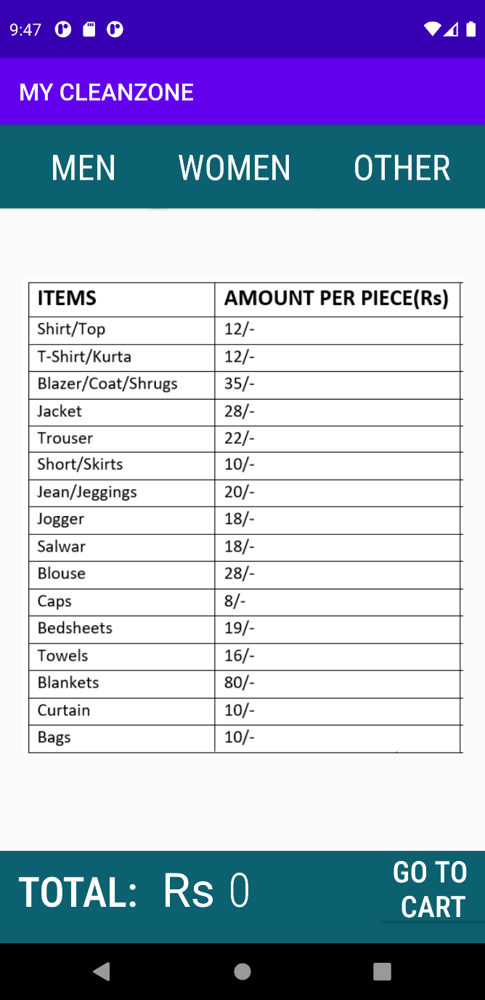

Wash_iron.xml

<**android.support.constraint.ConstraintLayout xmlns:android="http://schemas.android.com/apk/res/android"  
xmlns:app="http://schemas.android.com/apk/res-auto"  
xmlns:tools="http://schemas.android.com/tools"  
android:id="@+id/wash_frag"  
android:layout_width="match_parent"  
android:layout_height="match_parent"  
tools:context=".wash_iron"**>  
  
 <**Button  
 android:id="@+id/men"  
 android:layout_width="0dp"  
 android:layout_height="71dp"  
 android:layout_marginEnd="128dp"  
 android:background="@color/midnight_blue"  
 android:fontFamily="sans-serif-condensed"  
 android:text="men"  
 android:textColor="@color/white"  
 android:textSize="30dp"  
 app:layout_constraintEnd_toStartOf="@+id/other"  
 app:layout_constraintStart_toStartOf="parent"  
 app:layout_constraintTop_toTopOf="parent"** />  
  
 <**Button  
 android:id="@+id/women"  
 android:layout_width="0dp"  
 android:layout_height="71dp"  
 android:layout_marginStart="128dp"  
 android:background="@color/midnight_blue"  
 android:fontFamily="sans-serif-condensed"  
 android:text="women"  
 android:textColor="@color/white"  
 android:textSize="30dp"  
 app:layout_constraintEnd_toStartOf="@+id/other"  
 app:layout_constraintStart_toStartOf="parent"  
 app:layout_constraintTop_toTopOf="parent"** />  
  
 <**Button  
 android:id="@+id/other"  
 android:layout_width="0dp"  
 android:layout_height="71dp"  
 android:background="@color/midnight_blue"  
 android:fontFamily="sans-serif-condensed"  
 android:text="other"  
 android:textColor="@color/white"  
 android:textSize="30dp"  
 app:layout_constraintBaseline_toBaselineOf="@+id/women"  
 app:layout_constraintEnd_toEndOf="parent"  
 app:layout_constraintStart_toEndOf="@+id/women"** />  
  
  
 <**TextView  
 android:id="@+id/tot_amt"  
 android:layout_width="541dp"  
 android:layout_height="100dp"  
 android:background="@color/midnight_blue"  
 android:fontFamily="sans-serif-condensed-medium"  
 android:paddingLeft="15dp"  
 android:paddingTop="10dp"  
 android:text="TOTAL:"  
 android:textColor="@color/white"  
 android:textSize="35dp"  
 app:layout_constraintBaseline_toBaselineOf="@+id/rupee"  
 app:layout_constraintStart_toStartOf="parent"** />  
  
<**TextView  
 android:id="@+id/rupee"  
 android:layout_width="wrap_content"  
 android:layout_height="0dp"  
  
 android:layout_marginStart="137dp"  
 android:layout_marginEnd="11dp"  
 android:layout_marginBottom="20dp"  
 android:paddingTop="5dp"  
 android:text="Rs"  
 android:textColor="@color/white"  
 android:textSize="40dp"  
 app:layout_constraintBottom_toBottomOf="parent"  
 app:layout_constraintEnd_toStartOf="@+id/total"  
 app:layout_constraintStart_toStartOf="parent"** />  
  
 <**TextView  
 android:id="@+id/total"  
 android:layout_width="0dp"  
 android:layout_height="59dp"  
  
 android:fontFamily="sans-serif-condensed-light"  
 android:paddingTop="5dp"  
 android:text="0"  
 android:textColor="@color/white"  
 android:textSize="40dp"  
 app:layout_constraintBaseline_toBaselineOf="@+id/tot_amt"  
 app:layout_constraintEnd_toStartOf="@+id/cart"  
 app:layout_constraintStart_toEndOf="@+id/rupee"** />  
  
 <**Button  
 android:id="@+id/cart"  
 android:layout_width="wrap_content"  
 android:layout_height="0dp"  
 android:layout_marginBottom="19dp"  
 android:background="@color/midnight_blue"  
 android:fontFamily="sans-serif-condensed-medium"  
 android:text="GO TO \nCART"  
 android:textColor="@color/white"  
 android:textSize="25dp"  
 app:layout_constraintBottom_toBottomOf="parent"  
 app:layout_constraintEnd_toEndOf="parent"  
 app:layout_constraintStart_toEndOf="@+id/total"  
 app:layout_constraintTop_toTopOf="@+id/tot_amt"** />  
  
 <**ImageView  
 android:layout_width="412dp"  
 android:layout_height="405dp"  
 android:id="@+id/table1"  
 android:src="@drawable/table1"  
 tools:layout_editor_absoluteX="0dp"  
 app:layout_constraintBottom_toTopOf="@+id/tot_amt"  
 android:layout_marginBottom="80dp"  
 app:layout_constraintStart_toStartOf="parent"  
 tools:layout_editor_absoluteY="142dp"** />  
  
</**android.support.constraint.ConstraintLayout**>

Wash_iron.java

**package** com.example.mycleanzone;  
  
**import** android.content.Intent;  
**import** android.graphics.Color;  
**import** android.provider.ContactsContract;  
**import** android.support.v4.app.FragmentManager;  
**import** android.support.v7.app.AppCompatActivity;  
**import** android.os.Bundle;  
**import** android.view.View;  
**import** android.widget.Button;  
**import** android.widget.ImageView;  
**import** android.widget.TextView;  
  
**public class** wash_iron **extends** AppCompatActivity {  
 Button **men**,**women**,**other**,**cart**;  
 String **data**;  
 **public static** TextView *amt*;  
 ImageView **tb1**;  
  
 @Override  
 **protected void** onCreate(Bundle savedInstanceState) {  
 **super**.onCreate(savedInstanceState);  
 setContentView(R.layout.***activity_wash_iron***);  
 **men**=(Button)findViewById(R.id.***men***);  
 **women**=findViewById(R.id.***women***);  
 **other**=(Button)findViewById(R.id.***other***);  
 **cart**=findViewById(R.id.***cart***);  
 *amt*=(TextView)findViewById(R.id.***total***);  
 **tb1**=(ImageView)findViewById(R.id.***table1***);  
 Category.*choice*=1;  
  
 **men**.setOnClickListener(**new** View.OnClickListener() {  
 @Override  
 **public void** onClick(View v) {  
 *amt*.setText(**"0"**);  
 **tb1**.setImageResource(R.drawable.***blank***);  
 FragmentManager fm= getSupportFragmentManager();  
 fm.beginTransaction().replace(R.id.***wash_frag***, **new** men()).addToBackStack(**null**).commit();  
  
 }  
 });  
 **women**.setOnClickListener(**new** View.OnClickListener() {  
 @Override  
 **public void** onClick(View v) {  
 *amt*.setText(**"0"**);  
 **tb1**.setImageResource(R.drawable.***blank***);  
 FragmentManager fm= getSupportFragmentManager();  
 fm.beginTransaction().replace(R.id.***wash_frag***, **new** women()).addToBackStack(**null**).commit();  
 }  
 });  
 **other**.setOnClickListener(**new** View.OnClickListener() {  
 @Override  
 **public void** onClick(View v) {  
 *amt*.setText(**"0"**);  
 **tb1**.setImageResource(R.drawable.***blank***);  
 FragmentManager fm= getSupportFragmentManager();  
 fm.beginTransaction().replace(R.id.***wash_frag***, **new** other()).addToBackStack(**null**).commit();  
 }  
 });  
 **cart**.setOnClickListener(**new** View.OnClickListener() {  
 @Override  
 **public void** onClick(View v) {  
 Intent intent=**new** Intent(getApplicationContext(),payment.**class**);  
 intent.putExtra(**"data"**,**data**);  
 startActivity(intent);  
 }});  
  
  
 }  
  
 @Override  
 **protected void** onStart() {  
 **super**.onStart();  
 Intent intent=getIntent();  
 **data**=intent.getStringExtra(**"data"**);  
 }  
}

**Iron category:**

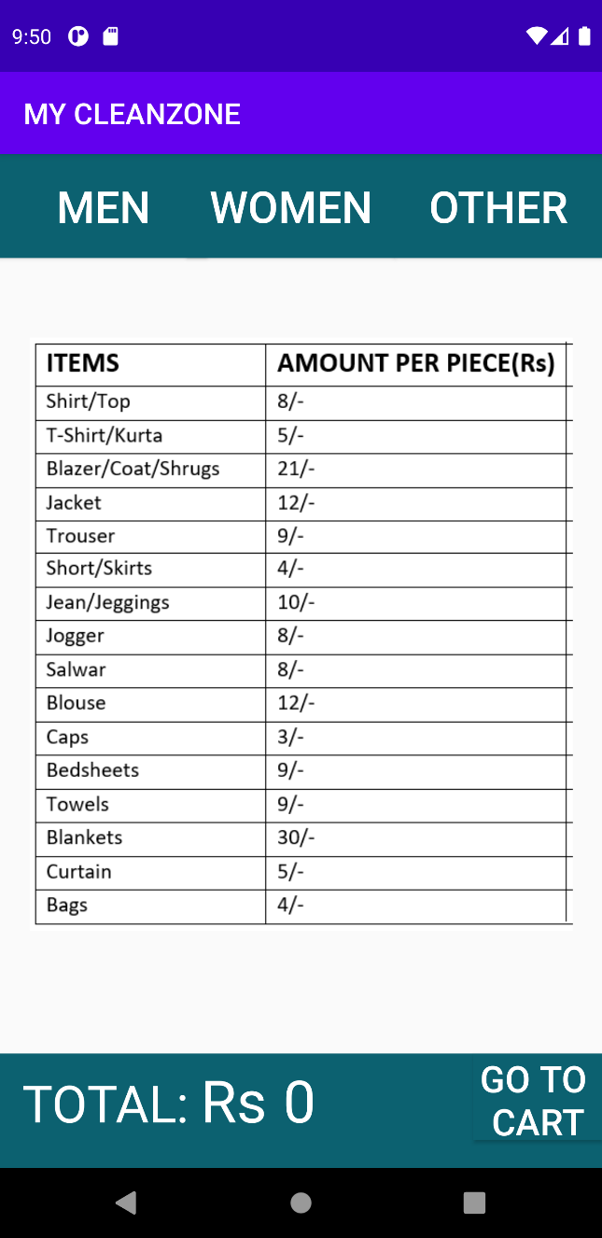

Iron.xml

*<?***xml version="1.0" encoding="utf-8"***?>*<**android.support.constraint.ConstraintLayout xmlns:android="http://schemas.android.com/apk/res/android"  
 xmlns:app="http://schemas.android.com/apk/res-auto"  
 xmlns:tools="http://schemas.android.com/tools"  
 android:id="@+id/iron_frag"  
 android:layout_width="match_parent"  
 android:layout_height="match_parent"  
 tools:context=".iron"**>  
  
 <**Button  
 android:id="@+id/men"  
 android:layout_width="0dp"  
 android:layout_height="71dp"  
 android:layout_marginEnd="128dp"  
 android:layout_marginBottom="307dp"  
 android:background="@color/midnight_blue"  
 android:text="men"  
 android:textColor="@color/white"  
 android:textSize="30dp"  
 app:layout_constraintEnd_toStartOf="@+id/other"  
 app:layout_constraintStart_toStartOf="parent"  
 app:layout_constraintTop_toTopOf="parent"** />  
  
 <**Button  
 android:id="@+id/women"  
 android:layout_width="0dp"  
 android:layout_height="71dp"  
 android:layout_marginStart="128dp"  
 android:background="@color/midnight_blue"  
 android:text="women"  
 android:textColor="@color/white"  
 android:textSize="30dp"  
 app:layout_constraintEnd_toStartOf="@+id/other"  
 app:layout_constraintStart_toStartOf="parent"  
 app:layout_constraintTop_toTopOf="parent"** />  
  
 <**Button  
 android:id="@+id/other"  
 android:layout_width="0dp"  
 android:layout_height="71dp"  
 android:background="@color/midnight_blue"  
 android:text="other"  
 android:textColor="@color/white"  
 android:textSize="30dp"  
 app:layout_constraintBaseline_toBaselineOf="@+id/women"  
 app:layout_constraintEnd_toEndOf="parent"  
 app:layout_constraintStart_toEndOf="@+id/women"** />  
  
  
  
 <**TextView  
 android:id="@+id/tot_amt"  
 android:layout_width="541dp"  
 android:layout_height="100dp"  
 android:background="@color/midnight_blue"  
 android:paddingLeft="15dp"  
 android:paddingTop="10dp"  
 android:text="TOTAL:"  
 android:textColor="@color/white"  
 android:textSize="35dp"  
 app:layout_constraintBaseline_toBaselineOf="@+id/rupee"  
 app:layout_constraintStart_toStartOf="parent"** />  
  
 <**TextView  
 android:id="@+id/rupee"  
 android:layout_width="wrap_content"  
 android:layout_height="0dp"  
  
 android:layout_marginStart="137dp"  
 android:layout_marginEnd="11dp"  
 android:layout_marginBottom="20dp"  
 android:paddingTop="5dp"  
 android:text="Rs"  
 android:textColor="@color/white"  
 android:textSize="40dp"  
 app:layout_constraintBottom_toBottomOf="parent"  
 app:layout_constraintEnd_toStartOf="@+id/total"  
 app:layout_constraintStart_toStartOf="parent"** />  
  
 <**TextView  
 android:id="@+id/total"  
 android:layout_width="0dp"  
 android:layout_height="59dp"  
  
 android:paddingTop="5dp"  
 android:text="0"  
 android:textColor="@color/white"  
 android:textSize="40dp"  
 app:layout_constraintBaseline_toBaselineOf="@+id/tot_amt"  
 app:layout_constraintEnd_toStartOf="@+id/cart"  
 app:layout_constraintStart_toEndOf="@+id/rupee"** />  
  
 <**Button  
 android:id="@+id/cart"  
 android:layout_width="wrap_content"  
 android:layout_height="0dp"  
 android:layout_marginBottom="19dp"  
 android:background="@color/midnight_blue"  
 android:text="GO TO \nCART"  
 android:textColor="@color/white"  
 android:textSize="25dp"  
 app:layout_constraintBottom_toBottomOf="parent"  
 app:layout_constraintEnd_toEndOf="parent"  
 app:layout_constraintStart_toEndOf="@+id/total"  
 app:layout_constraintTop_toTopOf="@+id/tot_amt"** />  
  
 <**ImageView  
 android:id="@+id/table2"  
 android:layout_width="412dp"  
 android:layout_height="405dp"  
 android:layout_marginBottom="84dp"  
 android:src="@drawable/table2"  
 app:layout_constraintBottom_toTopOf="@+id/tot_amt"  
 app:layout_constraintStart_toStartOf="parent"** />  
  
</**android.support.constraint.ConstraintLayout**>

Iron.java

**package** com.example.mycleanzone;  
  
**import** android.content.Intent;  
**import** android.provider.ContactsContract;  
**import** android.support.v4.app.Fragment;  
**import** android.support.v4.app.FragmentManager;  
**import** android.support.v4.app.FragmentTransaction;  
**import** android.support.v7.app.AppCompatActivity;  
**import** android.os.Bundle;  
**import** android.view.View;  
**import** android.widget.ImageView;  
**import** android.widget.Button;  
**import** android.widget.TextView;  
  
**import static** com.example.mycleanzone.R.drawable.*;  
  
**public class** iron **extends** AppCompatActivity {  
 Button **men**,**women**,**other**,**cart**;  
 String **data**;  
 **public static** TextView *amt*;  
ImageView **tb2**;  
  
 @Override  
 **protected void** onCreate(Bundle savedInstanceState) {  
 **super**.onCreate(savedInstanceState);  
 setContentView(R.layout.***activity_iron***);  
 **men**=(Button)findViewById(R.id.***men***);  
 **women**=findViewById(R.id.***women***);  
 **other**=(Button)findViewById(R.id.***other***);  
 **cart**=findViewById(R.id.***cart***);  
 *amt*=(TextView)findViewById(R.id.***total***);  
 Category.*choice*=2;  
 **tb2**=(ImageView)findViewById(R.id.***table2***);  
  
  
 **men**.setOnClickListener(**new** View.OnClickListener() {  
 @Override  
 **public void** onClick(View v) {  
 *amt*.setText(**"0"**);  
 **tb2**.setImageResource(***blank***);  
 FragmentManager fm= getSupportFragmentManager();  
 fm.beginTransaction().replace(R.id.***iron_frag***, **new** men()).addToBackStack(**null**).commit();  
  
  
 }  
 });  
 **women**.setOnClickListener(**new** View.OnClickListener() {  
 @Override  
 **public void** onClick(View v) {  
 *amt*.setText(**"0"**);  
 **tb2**.setImageResource(***blank***);  
 FragmentManager fm= getSupportFragmentManager();  
 fm.beginTransaction().replace(R.id.***iron_frag***, **new** women()).addToBackStack(**null**).commit();  
 }  
 });  
 **other**.setOnClickListener(**new** View.OnClickListener() {  
 @Override  
 **public void** onClick(View v) {  
 *amt*.setText(**"0"**);  
 **tb2**.setImageResource(***blank***);  
 FragmentManager fm= getSupportFragmentManager();  
 fm.beginTransaction().replace(R.id.***iron_frag***, **new** other()).addToBackStack(**null**).commit();  
 }  
 });  
 **cart**.setOnClickListener(**new** View.OnClickListener() {  
 @Override  
 **public void** onClick(View v) {  
 Intent intent=**new** Intent(getApplicationContext(),payment.**class**);  
 intent.putExtra(**"data"**,**data**);  
 startActivity(intent);  
 }});  
  
  
 }  
  
 @Override  
 **protected void** onStart() {  
 **super**.onStart();  
 Intent intent=getIntent();  
 **data**=intent.getStringExtra(**"data"**);  
 }  
}

**Dry_clean Screen:**

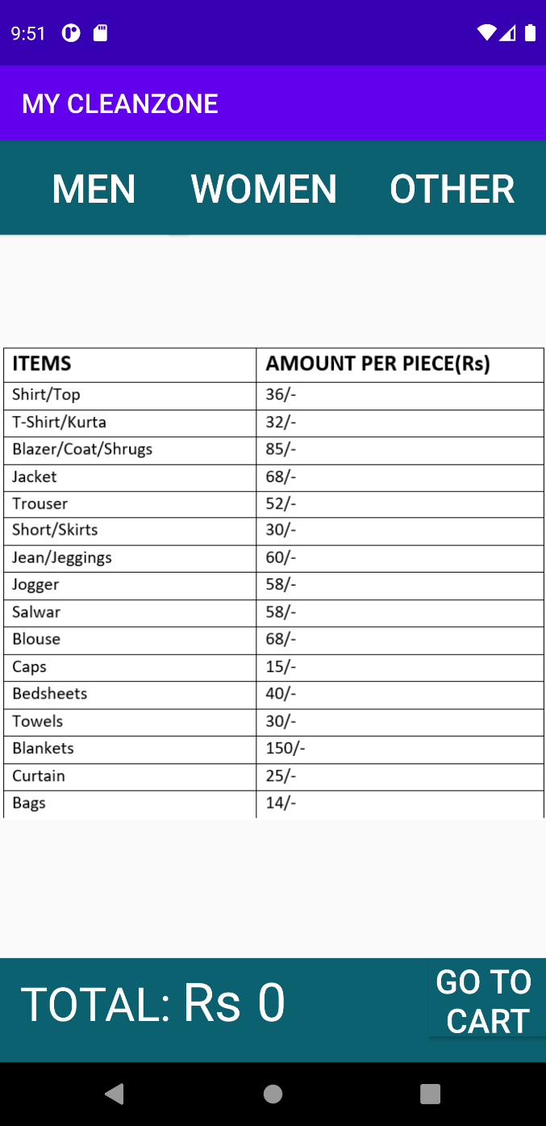

Dry_clean.xml

<**android.support.constraint.ConstraintLayout xmlns:android="http://schemas.android.com/apk/res/android"  
 xmlns:app="http://schemas.android.com/apk/res-auto"  
 xmlns:tools="http://schemas.android.com/tools"  
 android:id="@+id/dry_frag"  
 android:layout_width="match_parent"  
 android:layout_height="match_parent"  
 tools:context=".dry_clean"**>  
  
 <**Button  
 android:id="@+id/men"  
 android:layout_width="0dp"  
 android:layout_height="71dp"  
 android:layout_marginEnd="128dp"  
 android:layout_marginBottom="307dp"  
 android:background="@color/midnight_blue"  
 android:text="men"  
 android:textColor="@color/white"  
 android:textSize="30dp"  
 app:layout_constraintEnd_toStartOf="@+id/other"  
 app:layout_constraintStart_toStartOf="parent"  
 app:layout_constraintTop_toTopOf="parent"** />  
  
 <**Button  
 android:id="@+id/women"  
 android:layout_width="0dp"  
 android:layout_height="71dp"  
 android:layout_marginStart="128dp"  
 android:background="@color/midnight_blue"  
 android:text="women"  
 android:textColor="@color/white"  
 android:textSize="30dp"  
 app:layout_constraintEnd_toStartOf="@+id/other"  
 app:layout_constraintStart_toStartOf="parent"  
 app:layout_constraintTop_toTopOf="parent"** />  
  
 <**Button  
 android:id="@+id/other"  
 android:layout_width="0dp"  
 android:layout_height="71dp"  
 android:background="@color/midnight_blue"  
 android:text="other"  
 android:textColor="@color/white"  
 android:textSize="30dp"  
 app:layout_constraintBaseline_toBaselineOf="@+id/women"  
 app:layout_constraintEnd_toEndOf="parent"  
 app:layout_constraintStart_toEndOf="@+id/women"** />  
  
  
  
 <**TextView  
 android:id="@+id/tot_amt"  
 android:layout_width="541dp"  
 android:layout_height="100dp"  
 android:background="@color/midnight_blue"  
 android:paddingLeft="15dp"  
 android:paddingTop="10dp"  
 android:text="TOTAL:"  
 android:textColor="@color/white"  
 android:textSize="35dp"  
 app:layout_constraintBaseline_toBaselineOf="@+id/rupee"  
 app:layout_constraintStart_toStartOf="parent"** />  
  
 <**TextView  
 android:id="@+id/rupee"  
 android:layout_width="wrap_content"  
 android:layout_height="0dp"  
  
 android:layout_marginStart="137dp"  
 android:layout_marginEnd="11dp"  
 android:layout_marginBottom="20dp"  
 android:paddingTop="5dp"  
 android:text="Rs"  
 android:textColor="@color/white"  
 android:textSize="40dp"  
 app:layout_constraintBottom_toBottomOf="parent"  
 app:layout_constraintEnd_toStartOf="@+id/total"  
 app:layout_constraintStart_toStartOf="parent"** />  
  
 <**TextView  
 android:id="@+id/total"  
 android:layout_width="0dp"  
 android:layout_height="59dp"  
  
 android:paddingTop="5dp"  
 android:text="0"  
 android:textColor="@color/white"  
 android:textSize="40dp"  
 app:layout_constraintBaseline_toBaselineOf="@+id/tot_amt"  
 app:layout_constraintEnd_toStartOf="@+id/cart"  
 app:layout_constraintStart_toEndOf="@+id/rupee"** />  
  
 <**Button  
 android:id="@+id/cart"  
 android:layout_width="wrap_content"  
 android:layout_height="0dp"  
 android:layout_marginBottom="19dp"  
 android:background="@color/midnight_blue"  
 android:text="GO TO \nCART"  
 android:textColor="@color/white"  
 android:textSize="25dp"  
 app:layout_constraintBottom_toBottomOf="parent"  
 app:layout_constraintEnd_toEndOf="parent"  
 app:layout_constraintStart_toEndOf="@+id/total"  
 app:layout_constraintTop_toTopOf="@+id/tot_amt"** />  
 <**ImageView  
 android:layout_width="412dp"  
 android:layout_height="405dp"  
 android:src="@drawable/table3"  
 tools:layout_editor_absoluteX="0dp"  
 android:id="@+id/table3"  
 app:layout_constraintBottom_toTopOf="@+id/tot_amt"  
 android:layout_marginBottom="80dp"  
 app:layout_constraintStart_toStartOf="parent"  
 tools:layout_editor_absoluteY="142dp"** />  
  
</**android.support.constraint.ConstraintLayout**>

Dry_clean.java

**package** com.example.mycleanzone;  
  
**import** android.content.Intent;  
**import** android.provider.ContactsContract;  
**import** android.support.v4.app.FragmentManager;  
**import** android.support.v7.app.AppCompatActivity;  
**import** android.os.Bundle;  
**import** android.view.View;  
**import** android.widget.Button;  
**import** android.widget.ImageView;  
**import** android.widget.TextView;  
  
**public class** dry_clean **extends** AppCompatActivity {  
 Button **men**,**women**,**other**,**cart**;  
 String **data**;ImageView **tb3**;  
 **public static** TextView *amt*;  
  
 @Override  
 **protected void** onCreate(Bundle savedInstanceState) {  
 **super**.onCreate(savedInstanceState);  
 setContentView(R.layout.***activity_dry_clean***);  
 **men**=(Button)findViewById(R.id.***men***);  
 **women**=findViewById(R.id.***women***);  
 **other**=(Button)findViewById(R.id.***other***);  
 **cart**=findViewById(R.id.***cart***);  
 *amt*=(TextView)findViewById(R.id.***total***);  
 **tb3**=(ImageView)findViewById(R.id.***table3***);  
 Category.*choice*=3;  
  
 **men**.setOnClickListener(**new** View.OnClickListener() {  
 @Override  
 **public void** onClick(View v) {  
 *amt*.setText(**"0"**);**tb3**.setImageResource(R.drawable.***blank***);  
 FragmentManager fm= getSupportFragmentManager();  
 fm.beginTransaction().replace(R.id.***dry_frag***, **new** men()).addToBackStack(**null**).commit();  
  
 }  
 });  
 **women**.setOnClickListener(**new** View.OnClickListener() {  
 @Override  
 **public void** onClick(View v) {  
 *amt*.setText(**"0"**);**tb3**.setImageResource(R.drawable.***blank***);  
 FragmentManager fm= getSupportFragmentManager();  
 fm.beginTransaction().replace(R.id.***dry_frag***, **new** women()).addToBackStack(**null**).commit();  
 }  
 });  
 **other**.setOnClickListener(**new** View.OnClickListener() {  
 @Override  
 **public void** onClick(View v) {  
 *amt*.setText(**"0"**);  
 FragmentManager fm= getSupportFragmentManager();**tb3**.setImageResource(R.drawable.***blank***);  
 fm.beginTransaction().replace(R.id.***dry_frag***, **new** other()).addToBackStack(**null**).commit();  
 }  
 });  
 **cart**.setOnClickListener(**new** View.OnClickListener() {  
 @Override  
 **public void** onClick(View v) {  
 Intent intent=**new** Intent(getApplicationContext(),payment.**class**);  
 intent.putExtra(**"data"**,**data**);  
 startActivity(intent);  
 }});  
  
  
 }  
  
 @Override  
 **protected void** onStart() {  
 **super**.onStart();  
 Intent intent=getIntent();  
 **data**=intent.getStringExtra(**"data"**);  
 }  
}

**Men (fragment):**

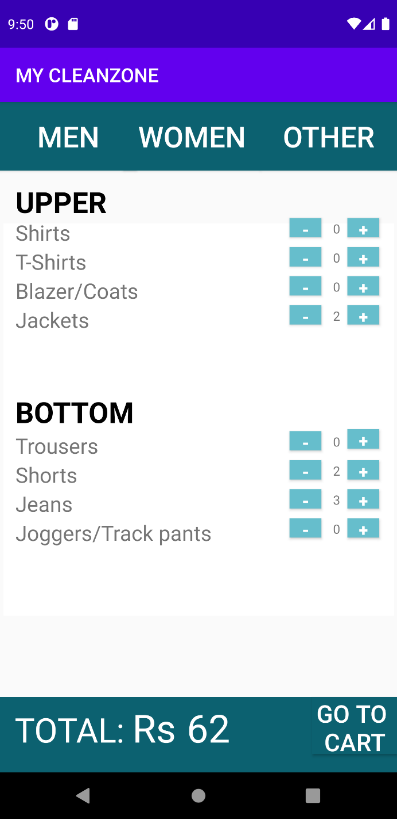

Men.xml

*<?***xml version="1.0" encoding="utf-8"***?>*<**FrameLayout xmlns:android="http://schemas.android.com/apk/res/android"  
 xmlns:app="http://schemas.android.com/apk/res-auto"  
 xmlns:tools="http://schemas.android.com/tools"  
 android:id="@+id/men_frag"  
 android:layout_width="match_parent"  
 android:layout_height="match_parent"  
 tools:context=".men"**>  
  
 *<!--* ***TODO: Update blank fragment layout*** *-->* <**TextView  
 android:id="@+id/upper"  
 android:layout_width="wrap_content"  
 android:layout_height="wrap_content"  
 android:layout_marginStart="16dp"  
 android:layout_marginTop="83dp"  
 android:text="UPPER"  
 android:textColor="@color/black"  
 android:textSize="30dp"  
 android:textStyle="bold"** />  
  
  
 <**TextView  
 android:id="@+id/shirts"  
 android:layout_width="wrap_content"  
 android:layout_height="wrap_content"  
 android:layout_marginStart="16dp"  
 android:layout_marginTop="120dp"  
 android:layout_marginEnd="176dp"  
 android:text="Shirts"  
 android:textSize="22dp"** />  
  
 <**Button  
 android:id="@+id/shirt_dec"  
 android:layout_width="33dp"  
 android:layout_height="20dp"  
 android:background="@color/blue"  
 android:textColor="@color/white"  
 android:textSize="17dp"  
 android:layout_marginLeft="300dp"  
 android:layout_marginTop="120dp"  
  
 android:text="-"  
  
  
 android:textStyle="bold"** />  
  
 <**TextView  
 android:id="@+id/shirt_counter"  
 android:layout_width="wrap_content"  
 android:layout_height="wrap_content"  
 android:layout_marginTop="122dp"  
 android:text="0"  
 android:inputType="number"  
  
 android:layout_marginLeft="345dp"  
 android:textSize="13dp"** />  
  
  
 <**Button  
 android:layout_width="33dp"  
 android:layout_height="20dp"  
 android:layout_marginTop="120dp"  
 android:background="@color/blue"  
 android:textColor="@color/white"  
 android:textSize="17dp"  
  
 android:text="+"  
 android:layout_marginLeft="360dp"  
 android:id="@+id/shirt_inc"  
  
 android:textStyle="bold"** />  
  
 <**TextView  
 android:id="@+id/tshirt"  
 android:layout_width="wrap_content"  
 android:layout_height="wrap_content"  
 android:layout_marginStart="16dp"  
 android:layout_marginTop="150dp"  
 android:text="T-Shirts"  
 android:textSize="22dp"** />  
 <**Button  
 android:id="@+id/tshirt_dec"  
 android:layout_width="33dp"  
 android:layout_height="20dp"  
 android:background="@color/blue"  
 android:textColor="@color/white"  
 android:textSize="17dp"  
 android:layout_marginTop="150dp"  
 android:layout_marginLeft="300dp"  
 android:text="-"  
  
 android:textStyle="bold"** />  
 <**TextView  
 android:id="@+id/tshirt_counter"  
 android:layout_width="wrap_content"  
 android:layout_height="wrap_content"  
 android:layout_marginTop="152dp"  
 android:text="0"  
 android:inputType="number"  
  
 android:layout_marginLeft="345dp"  
 android:textSize="13dp"** />  
  
  
 <**Button  
 android:layout_width="33dp"  
 android:layout_height="20dp"  
  
 android:background="@color/blue"  
 android:textColor="@color/white"  
 android:textSize="17dp"  
 android:layout_marginTop="150dp"  
 android:text="+"  
 android:layout_marginLeft="360dp"  
 android:id="@+id/tshirt_inc"  
 android:textStyle="bold"** />  
 <**TextView  
 android:id="@+id/coat"  
 android:layout_width="wrap_content"  
 android:layout_height="wrap_content"  
 android:layout_marginStart="16dp"  
 android:layout_marginTop="180dp"  
 android:text="Blazer/Coats"  
 android:textSize="22dp"** />  
 <**Button  
 android:id="@+id/coat_dec"  
 android:layout_width="33dp"  
 android:layout_height="20dp"  
  
 android:background="@color/blue"  
 android:textColor="@color/white"  
 android:textSize="17dp"  
 android:layout_marginTop="180dp"  
 android:layout_marginLeft="300dp"  
 android:text="-"  
  
 android:textStyle="bold"** />  
 <**TextView  
 android:id="@+id/coat_counter"  
 android:layout_width="wrap_content"  
 android:layout_height="wrap_content"  
 android:layout_marginTop="182dp"  
 android:text="0"  
 android:inputType="number"  
  
 android:layout_marginLeft="345dp"  
 android:textSize="13dp"** />  
  
  
 <**Button  
 android:layout_width="33dp"  
 android:layout_height="20dp"  
  
 android:background="@color/blue"  
 android:textColor="@color/white"  
 android:textSize="17dp"  
 android:layout_marginTop="180dp"  
 android:text="+"  
 android:layout_marginLeft="360dp"  
 android:id="@+id/coat_inc"  
 android:textStyle="bold"** />  
 <**TextView  
 android:id="@+id/jacket"  
 android:layout_width="wrap_content"  
 android:layout_height="wrap_content"  
 android:layout_marginStart="16dp"  
 android:layout_marginTop="210dp"  
 android:text="Jackets"  
 android:textSize="22dp"** />  
 <**Button  
 android:id="@+id/jacket_dec"  
 android:layout_width="33dp"  
 android:layout_height="20dp"  
  
 android:background="@color/blue"  
 android:textColor="@color/white"  
 android:textSize="17dp"  
 android:layout_marginTop="210dp"  
 android:layout_marginLeft="300dp"  
 android:text="-"  
  
 android:textStyle="bold"** />  
 <**TextView  
 android:id="@+id/jacket_counter"  
 android:layout_width="wrap_content"  
 android:layout_height="wrap_content"  
 android:layout_marginTop="212dp"  
 android:text="0"  
  
  
 android:layout_marginStart="345dp"  
 android:textSize="13dp"** />  
  
  
 <**Button  
 android:layout_width="33dp"  
 android:layout_height="20dp"  
  
 android:background="@color/blue"  
 android:textColor="@color/white"  
 android:textSize="17dp"  
 android:layout_marginTop="210dp"  
 android:text="+"  
 android:layout_marginLeft="360dp"  
 android:id="@+id/jacket_inc"  
  
 android:textStyle="bold"** />  
 <**TextView  
 android:id="@+id/textView9"  
 android:layout_width="wrap_content"  
 android:layout_height="wrap_content"  
 android:layout_marginStart="16dp"  
 android:text="BOTTOM"  
 android:layout_marginTop="300dp"  
 android:textColor="@color/black"  
 android:textSize="30dp"  
 android:textStyle="bold"** />  
 <**TextView  
 android:layout_width="wrap_content"  
 android:layout_height="wrap_content"  
 android:layout_marginStart="16dp"  
 android:layout_marginTop="340dp"  
 android:text="Trousers"  
 android:textSize="22dp"**/>  
  
 <**Button  
 android:id="@+id/trouser_dec"  
 android:layout_width="33dp"  
 android:layout_height="20dp"  
  
 android:background="@color/blue"  
 android:textColor="@color/white"  
 android:textSize="17dp"  
 android:layout_marginTop="340dp"  
 android:layout_marginLeft="300dp"  
 android:text="-"  
 android:textStyle="bold"** />  
 <**TextView  
 android:id="@+id/trouser_counter"  
 android:layout_width="wrap_content"  
 android:layout_height="wrap_content"  
 android:layout_marginTop="342dp"  
 android:text="0"  
 android:inputType="number"  
  
 android:layout_marginLeft="345dp"  
 android:textSize="13dp"** />  
  
  
 <**Button  
 android:layout_width="33dp"  
 android:layout_height="20dp"  
  
 android:background="@color/blue"  
 android:textColor="@color/white"  
 android:textSize="17dp"  
 android:layout_marginTop="338dp"  
 android:text="+"  
 android:layout_marginLeft="360dp"  
 android:id="@+id/trouser_inc"  
 android:textStyle="bold"** />  
 <**TextView  
 android:layout_width="wrap_content"  
 android:layout_height="wrap_content"  
 android:layout_marginStart="16dp"  
 android:layout_marginTop="370dp"  
 android:text="Shorts"  
 android:textSize="22dp"**/>  
  
 <**Button  
 android:id="@+id/shorts_dec"  
 android:layout_width="33dp"  
 android:layout_height="20dp"  
  
 android:background="@color/blue"  
 android:textColor="@color/white"  
 android:textSize="17dp"  
 android:layout_marginTop="370dp"  
 android:layout_marginLeft="300dp"  
 android:text="-"  
 android:textStyle="bold"** />  
 <**TextView  
 android:id="@+id/shorts_counter"  
 android:layout_width="wrap_content"  
 android:layout_height="wrap_content"  
 android:layout_marginTop="372dp"  
 android:text="0"  
 android:inputType="number"  
  
 android:layout_marginLeft="345dp"  
 android:textSize="13dp"** />  
  
  
 <**Button  
 android:layout_width="33dp"  
 android:layout_height="20dp"  
  
 android:background="@color/blue"  
 android:textColor="@color/white"  
 android:textSize="17dp"  
 android:layout_marginTop="370dp"  
 android:text="+"  
 android:layout_marginLeft="360dp"  
 android:id="@+id/shorts_inc"  
 android:textStyle="bold"** />  
 <**TextView  
 android:layout_width="wrap_content"  
 android:layout_height="wrap_content"  
 android:layout_marginStart="16dp"  
 android:layout_marginTop="400dp"  
 android:text="Jeans"  
 android:textSize="22dp"**/>  
  
 <**Button  
 android:id="@+id/jean_dec"  
 android:layout_width="33dp"  
 android:layout_height="20dp"  
  
 android:background="@color/blue"  
 android:textColor="@color/white"  
 android:textSize="17dp"  
 android:layout_marginTop="400dp"  
 android:layout_marginLeft="300dp"  
 android:text="-"  
 android:textStyle="bold"** />  
 <**TextView  
 android:id="@+id/jean_counter"  
 android:layout_width="wrap_content"  
 android:layout_height="wrap_content"  
 android:layout_marginTop="402dp"  
 android:text="0"  
 android:inputType="number"  
  
 android:layout_marginLeft="345dp"  
 android:textSize="13dp"** />  
  
  
 <**Button  
 android:layout_width="33dp"  
 android:layout_height="20dp"  
  
 android:background="@color/blue"  
 android:textColor="@color/white"  
 android:textSize="17dp"  
 android:layout_marginTop="400dp"  
 android:text="+"  
 android:layout_marginLeft="360dp"  
 android:id="@+id/jean_inc"  
 android:textStyle="bold"** />  
 <**TextView  
 android:layout_width="wrap_content"  
 android:layout_height="wrap_content"  
 android:layout_marginStart="16dp"  
 android:layout_marginTop="430dp"  
 android:text="Joggers/Track pants"  
 android:textSize="22dp"**/>  
  
 <**Button  
 android:id="@+id/jogger_dec"  
 android:layout_width="33dp"  
 android:layout_height="20dp"  
  
 android:background="@color/blue"  
 android:textColor="@color/white"  
 android:textSize="17dp"  
 android:layout_marginTop="430dp"  
 android:layout_marginLeft="300dp"  
 android:text="-"  
 android:textStyle="bold"** />  
 <**TextView  
 android:id="@+id/jogger_counter"  
 android:layout_width="wrap_content"  
 android:layout_height="wrap_content"  
 android:layout_marginTop="432dp"  
 android:text="0"  
 android:inputType="number"  
  
 android:layout_marginLeft="345dp"  
 android:textSize="13dp"** />  
  
  
 <**Button  
 android:layout_width="33dp"  
 android:layout_height="20dp"  
  
 android:background="@color/blue"  
 android:textColor="@color/white"  
 android:textSize="17dp"  
 android:layout_marginTop="430dp"  
 android:text="+"  
 android:layout_marginLeft="360dp"  
 android:id="@+id/jogger_inc"  
 android:textStyle="bold"** />  
  
  
  
  
  
  
  
  
  
</**FrameLayout**>

Men.class

**package** com.example.mycleanzone;  
  
**import** android.content.Intent;  
**import** android.os.Bundle;  
**import** android.support.v4.app.Fragment;  
**import** android.view.LayoutInflater;  
**import** android.view.View;  
**import** android.view.ViewGroup;  
**import** android.widget.Button;  
**import** android.widget.TextView;  
  
*/**  
 * A simple {****@link*** *Fragment} subclass.  
 * Use the {****@link*** *women#newInstance} factory method to  
 * create an instance of this fragment.  
 */***public class** men **extends** Fragment {  
  
 *//* ***TODO: Rename parameter arguments, choose names that match*** *// the fragment initialization parameters, e.g. ARG_ITEM_NUMBER* **private static final** String ***ARG_PARAM1*** = **"param1"**;  
 **private static final** String ***ARG_PARAM2*** = **"param2"**;  
 **public** String **mParam3**=**" "**;  
  
  
 *//* ***TODO: Rename and change types of parameters* private** String **mParam1**;  
 **private** String **mParam2**;  
  
 **public** men() {  
 *// Required empty public constructor* }  
  
 */**  
 * Use this factory method to create a new instance of  
 * this fragment using the provided parameters.  
 *  
 \** ***@param param1*** *Parameter 1.  
 \** ***@param param2*** *Parameter 2.  
 \** ***@return*** *A new instance of fragment women.  
 */  
 //* ***TODO: Rename and change types and number of parameters* public static** men newInstance(String param1, String param2) {  
 men fragment = **new** men();  
 Bundle args = **new** Bundle();  
 args.putString(***ARG_PARAM1***, param1);  
 args.putString(***ARG_PARAM2***, param2);  
 fragment.setArguments(args);  
 **return** fragment;  
 }  
  
 Button **shirt_inc**, **tshirt_inc**, **blazer_inc**, **jacket_inc**;  
 Button **shirt_dec**, **tshirt_dec**, **blazer_dec**, **jacket_dec**;  
 TextView **shirt_count**, **tshirt_count**, **blazer_count**, **jacket_count**, **amt**;  
 Button **trouser_inc**,**short_inc**,**jean_inc**,**jogger_inc**;  
 Button **trouser_dec**,**short_dec**,**jean_dec**,**jogger_dec**;  
 TextView **trouser_count**,**short_count**,**jean_count**,**jogger_count**;  
 wash_iron **wi**;  
 **public static int** *men_tot*=0;  
 **public static int** *men_qt*=0;  
  
  
  
  
 @Override  
 **public void** onCreate(Bundle savedInstanceState) {  
 **super**.onCreate(savedInstanceState);  
 **if** (getArguments() != **null**) {  
 **mParam1** = getArguments().getString(***ARG_PARAM1***);  
 **mParam2** = getArguments().getString(***ARG_PARAM2***);  
 **mParam3** = getArguments().getString(**"params"**);  
 }  
 }  
  
 @Override  
 **public** View onCreateView(LayoutInflater inflater, ViewGroup container,  
 Bundle savedInstanceState) {  
 *// Inflate the layout for this fragment* View v = inflater.inflate(R.layout.***fragment_men***, container, **false**);  
  
  
 **wi**=**new** wash_iron();  
 **shirt_inc** = (Button) v.findViewById(R.id.***shirt_inc***);  
 **shirt_dec** = (Button) v.findViewById(R.id.***shirt_dec***);  
 **shirt_count** = (TextView) v.findViewById(R.id.***shirt_counter***);  
 **shirt_inc**.setOnClickListener(**new** shirt_inc());  
 **shirt_dec**.setOnClickListener(**new** shirt_dec());  
 **tshirt_inc** = (Button) v.findViewById(R.id.***tshirt_inc***);  
 **tshirt_dec** = (Button) v.findViewById(R.id.***tshirt_dec***);  
 **tshirt_count** = (TextView) v.findViewById(R.id.***tshirt_counter***);  
 **tshirt_inc**.setOnClickListener(**new** tshirt_inc());  
 **tshirt_dec**.setOnClickListener(**new** tshirt_dec());  
 **blazer_inc** = (Button) v.findViewById(R.id.***coat_inc***);  
 **blazer_dec** = (Button) v.findViewById(R.id.***coat_dec***);  
 **blazer_count** = (TextView) v.findViewById(R.id.***coat_counter***);  
 **blazer_inc**.setOnClickListener(**new** blazer_inc());  
 **blazer_dec**.setOnClickListener(**new** blazer_dec());  
 **jacket_inc** = (Button) v.findViewById(R.id.***jacket_inc***);  
 **jacket_dec** = (Button) v.findViewById(R.id.***jacket_dec***);  
 **jacket_count** = (TextView) v.findViewById(R.id.***jacket_counter***);  
 **jacket_inc**.setOnClickListener(**new** jacket_inc());  
 **jacket_dec**.setOnClickListener(**new** jacket_dec());  
 **trouser_inc** = (Button) v.findViewById(R.id.***trouser_inc***);  
 **trouser_dec** = (Button) v.findViewById(R.id.***trouser_dec***);  
 **trouser_count** = (TextView) v.findViewById(R.id.***trouser_counter***);  
 **trouser_inc**.setOnClickListener(**new** trouser_inc());  
 **trouser_dec**.setOnClickListener(**new** trouser_dec());  
 **short_inc** = (Button) v.findViewById(R.id.***shorts_inc***);  
 **short_dec** = (Button) v.findViewById(R.id.***shorts_dec***);  
 **short_count** = (TextView) v.findViewById(R.id.***shorts_counter***);  
 **short_inc**.setOnClickListener(**new** short_inc());  
 **short_dec**.setOnClickListener(**new** short_dec());  
 **jean_inc** = (Button) v.findViewById(R.id.***jean_inc***);  
 **jean_dec** = (Button) v.findViewById(R.id.***jean_dec***);  
 **jean_count** = (TextView) v.findViewById(R.id.***jean_counter***);  
 **jean_inc**.setOnClickListener(**new** jean_inc());  
 **jean_dec**.setOnClickListener(**new** jean_dec());  
 **jogger_inc** = (Button) v.findViewById(R.id.***jogger_inc***);  
 **jogger_dec** = (Button) v.findViewById(R.id.***jogger_dec***);  
 **jogger_count** = (TextView) v.findViewById(R.id.***jogger_counter***);  
 **jogger_inc**.setOnClickListener(**new** jogger_inc());  
 **jogger_dec**.setOnClickListener(**new** jogger_dec());  
 Intent intent=**new** Intent(getActivity().getBaseContext(),wash_iron.**class**);  
 intent.putExtra(**"data"**,Integer.*toString*(*men_tot*));  
 **return** v;  
 }  
  
 **void** total() {  
 **int** shirt_amt = Integer.*parseInt*(**shirt_count**.getText().toString()) ;  
 **int** tshirt_amt = Integer.*parseInt*(**tshirt_count**.getText().toString()) ;  
 **int** blazer_amt = Integer.*parseInt*(**blazer_count**.getText().toString()) ;  
 **int** jacket_amt = Integer.*parseInt*(**jacket_count**.getText().toString()) ;  
 **int** trouser_amt=Integer.*parseInt*(**trouser_count**.getText().toString());  
 **int** short_amt=Integer.*parseInt*(**short_count**.getText().toString()) ;  
 **int** jean_amt=Integer.*parseInt*(**jean_count**.getText().toString()) ;  
 **int** jogger_amt=Integer.*parseInt*(**jogger_count**.getText().toString()) ;  
 *men_qt*=shirt_amt + tshirt_amt + blazer_amt + jacket_amt+trouser_amt+short_amt*+jean_amt+jogger_amt;  
 **if**(Category.*choice*==1){  
 *men_tot* = shirt_amt*12 + tshirt_amt*12 + blazer_amt*35 + jacket_amt*28+trouser_amt*22+short_amt*10+jean_amt*20+jogger_amt*18;  
 wash_iron.*amt*.setText(Integer.*toString*(*men_tot*));}  
 **else if**(Category.*choice*==2){  
 *men_tot* = shirt_amt*6 + tshirt_amt*4 + blazer_amt*18 + jacket_amt*12+trouser_amt*10+short_amt*4+jean_amt*10+jogger_amt*8;  
 iron.*amt*.setText(Integer.*toString*(*men_tot*));}  
 **else if**(Category.*choice*==3){  
 *men_tot* = shirt_amt*26 + tshirt_amt*24 + blazer_amt*68 + jacket_amt*42+trouser_amt*30+short_amt*34+jean_amt*50+jogger_amt*38;  
 dry_clean.*amt*.setText(Integer.*toString*(*men_tot*));  
 }  
  
  
  
 }  
  
 **void** increment(TextView tv) {  
 String s = tv.getText().toString();  
 **int** ss = Integer.*parseInt*(s);  
 ss++;  
 String sss = Integer.*toString*(ss);  
 tv.setText(sss);  
 total();  
 }  
  
 **void** decrement(TextView tv) {  
 String s = tv.getText().toString();  
 **int** ss = Integer.*parseInt*(s);  
 **if** (ss > 0)  
 ss--;  
 **else** ss = 0;  
 String sss = Integer.*toString*(ss);  
 tv.setText(sss);  
 total();  
 }  
  
 **class** shirt_inc **implements** View.OnClickListener {  
 @Override  
 **public void** onClick(View v) {  
 increment(**shirt_count**);  
 }  
 }  
  
 **class** shirt_dec **implements** View.OnClickListener {  
 @Override  
 **public void** onClick(View v) {  
 decrement(**shirt_count**);  
  
 }  
  
 }  
  
 **class** tshirt_inc **implements** View.OnClickListener {  
 @Override  
 **public void** onClick(View v) {  
 increment(**tshirt_count**);  
 }  
 }  
  
 **class** tshirt_dec **implements** View.OnClickListener {  
 @Override  
 **public void** onClick(View v) {  
 decrement(**tshirt_count**);  
 }  
  
 }  
  
 **class** blazer_inc **implements** View.OnClickListener {  
 @Override  
 **public void** onClick(View v) {  
 increment(**blazer_count**);  
 }  
 }  
  
 **class** blazer_dec **implements** View.OnClickListener {  
 @Override  
 **public void** onClick(View v) {  
 decrement(**blazer_count**);  
 }  
  
 }  
  
 **class** jacket_inc **implements** View.OnClickListener {  
 @Override  
 **public void** onClick(View v) {  
 increment(**jacket_count**);  
 }  
 }  
  
 **class** jacket_dec **implements** View.OnClickListener {  
 @Override  
 **public void** onClick(View v) {  
 decrement(**jacket_count**);  
 }  
  
 }  
 **class** trouser_inc **implements** View.OnClickListener {  
 @Override  
 **public void** onClick(View v) {  
 increment(**trouser_count**);  
 }  
 }  
  
 **class** trouser_dec **implements** View.OnClickListener {  
 @Override  
 **public void** onClick(View v) {  
 decrement(**trouser_count**);  
  
 }  
  
 }  
 **class** short_inc **implements** View.OnClickListener {  
 @Override  
 **public void** onClick(View v) {  
 increment(**short_count**);  
 }  
 }  
  
 **class** short_dec **implements** View.OnClickListener {  
 @Override  
 **public void** onClick(View v) {  
 decrement(**short_count**);  
  
 }  
  
 }  
 **class** jean_inc **implements** View.OnClickListener {  
 @Override  
 **public void** onClick(View v) {  
 increment(**jean_count**);  
 }  
 }  
  
 **class** jean_dec **implements** View.OnClickListener {  
 @Override  
 **public void** onClick(View v) {  
 decrement(**jean_count**);  
  
 }  
  
 }  
 **class** jogger_inc **implements** View.OnClickListener {  
 @Override  
 **public void** onClick(View v) {  
 increment(**jogger_count**);  
 }  
 }  
  
 **class** jogger_dec **implements** View.OnClickListener {  
 @Override  
 **public void** onClick(View v) {  
 decrement(**jogger_count**);  
  
 }  
  
 }  
}

**Women (fragment):**

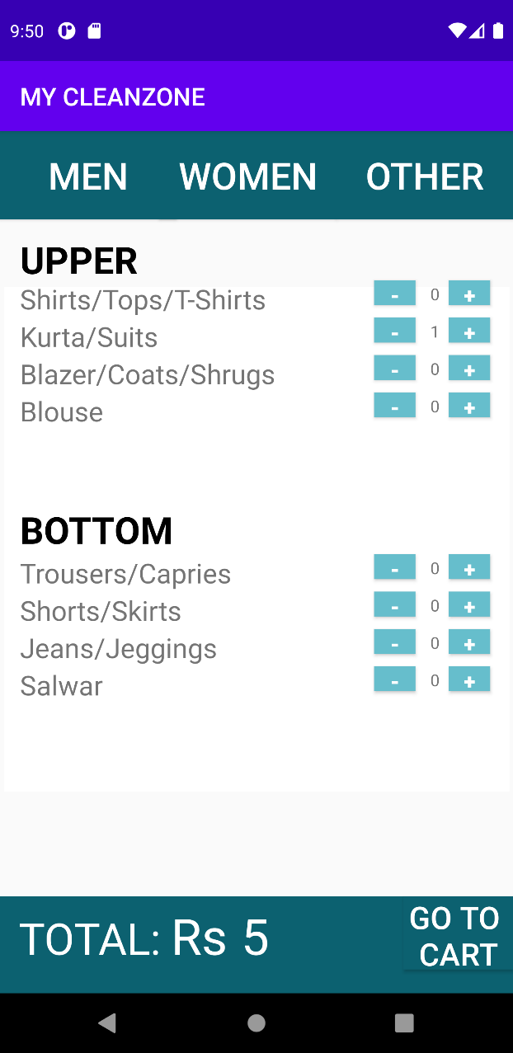

Women.xml

*<?***xml version="1.0" encoding="utf-8"***?>*<**FrameLayout xmlns:android="http://schemas.android.com/apk/res/android"  
 xmlns:app="http://schemas.android.com/apk/res-auto"  
 xmlns:tools="http://schemas.android.com/tools"  
 android:layout_width="match_parent"  
 android:id="@+id/women_frag"  
 android:layout_height="match_parent"  
 tools:context=".women"**>  
  
 *<!--* ***TODO: Update blank fragment layout*** *-->* <**TextView  
 android:id="@+id/upper"  
 android:layout_width="wrap_content"  
 android:layout_height="wrap_content"  
 android:layout_marginStart="16dp"  
 android:layout_marginTop="83dp"  
 android:text="UPPER"  
 android:textColor="@color/black"  
 android:textSize="30dp"  
 android:textStyle="bold"** />  
  
  
 <**TextView  
 android:id="@+id/wshirts"  
 android:layout_width="wrap_content"  
 android:layout_height="wrap_content"  
 android:layout_marginStart="16dp"  
 android:layout_marginTop="120dp"  
 android:layout_marginEnd="176dp"  
 android:text="Shirts/Tops/T-Shirts"  
 android:textSize="22dp"** />  
  
 <**Button  
 android:id="@+id/wshirt_dec"  
 android:layout_width="33dp"  
 android:layout_height="20dp"  
  
 android:background="@color/blue"  
 android:textColor="@color/white"  
 android:textSize="17dp"  
 android:layout_marginTop="120dp"  
  
 android:layout_marginLeft="300dp"  
 android:text="-"  
 android:textStyle="bold"** />  
  
 <**TextView  
 android:id="@+id/wshirt_counter"  
 android:layout_width="wrap_content"  
 android:layout_height="wrap_content"  
 android:layout_marginTop="122dp"  
 android:text="0"  
 android:inputType="number"  
  
 android:layout_marginLeft="345dp"  
 android:textSize="13dp"** />  
  
  
 <**Button  
 android:layout_width="33dp"  
 android:layout_height="20dp"  
  
 android:background="@color/blue"  
 android:textColor="@color/white"  
 android:textSize="17dp"  
 android:layout_marginTop="120dp"  
 android:text="+"  
 android:layout_marginLeft="360dp"  
 android:id="@+id/wshirt_inc"  
 android:textStyle="bold"** />  
  
 <**TextView  
 android:id="@+id/kurta"  
 android:layout_width="wrap_content"  
 android:layout_height="wrap_content"  
 android:layout_marginStart="16dp"  
 android:layout_marginTop="150dp"  
 android:text="Kurta/Suits"  
 android:textSize="22dp"** />  
 <**Button  
 android:id="@+id/kurta_dec"  
 android:layout_width="33dp"  
 android:layout_height="20dp"  
  
 android:background="@color/blue"  
 android:textColor="@color/white"  
 android:textSize="17dp"  
 android:layout_marginTop="150dp"  
 android:layout_marginLeft="300dp"  
 android:text="-"  
 android:textStyle="bold"** />  
 <**TextView  
 android:id="@+id/kurta_counter"  
 android:layout_width="wrap_content"  
 android:layout_height="wrap_content"  
 android:layout_marginTop="152dp"  
 android:text="0"  
 android:inputType="number"  
  
 android:layout_marginLeft="345dp"  
 android:textSize="13dp"** />  
  
  
 <**Button  
 android:layout_width="33dp"  
 android:layout_height="20dp"  
  
 android:background="@color/blue"  
 android:textColor="@color/white"  
 android:textSize="17dp"  
 android:layout_marginTop="150dp"  
 android:text="+"  
 android:layout_marginLeft="360dp"  
 android:id="@+id/kurta_inc"  
 android:textStyle="bold"** />  
 <**TextView  
 android:id="@+id/wcoat"  
 android:layout_width="wrap_content"  
 android:layout_height="wrap_content"  
 android:layout_marginStart="16dp"  
 android:layout_marginTop="180dp"  
 android:text="Blazer/Coats/Shrugs"  
 android:textSize="22dp"** />  
 <**Button  
 android:id="@+id/wcoat_dec"  
 android:layout_width="33dp"  
 android:layout_height="20dp"  
  
 android:background="@color/blue"  
 android:textColor="@color/white"  
 android:textSize="17dp"  
 android:layout_marginTop="180dp"  
 android:layout_marginLeft="300dp"  
 android:text="-"  
 android:textStyle="bold"** />  
 <**TextView  
 android:id="@+id/wcoat_counter"  
 android:layout_width="wrap_content"  
 android:layout_height="wrap_content"  
 android:layout_marginTop="182dp"  
 android:text="0"  
 android:inputType="number"  
  
 android:layout_marginLeft="345dp"  
 android:textSize="13dp"** />  
  
  
 <**Button  
 android:layout_width="33dp"  
 android:layout_height="20dp"  
  
 android:background="@color/blue"  
 android:textColor="@color/white"  
 android:textSize="17dp"  
 android:layout_marginTop="180dp"  
 android:text="+"  
 android:layout_marginLeft="360dp"  
 android:id="@+id/wcoat_inc"  
 android:textStyle="bold"** />  
 <**TextView  
 android:id="@+id/blouse"  
 android:layout_width="wrap_content"  
 android:layout_height="wrap_content"  
 android:layout_marginStart="16dp"  
 android:layout_marginTop="210dp"  
 android:text="Blouse"  
 android:textSize="22dp"** />  
 <**Button  
 android:id="@+id/blouse_dec"  
 android:layout_width="33dp"  
 android:layout_height="20dp"  
  
 android:background="@color/blue"  
 android:textColor="@color/white"  
 android:textSize="17dp"  
 android:layout_marginTop="210dp"  
 android:layout_marginLeft="300dp"  
 android:text="-"  
 android:textStyle="bold"** />  
 <**TextView  
 android:id="@+id/blouse_counter"  
 android:layout_width="wrap_content"  
 android:layout_height="wrap_content"  
 android:layout_marginTop="212dp"  
 android:text="0"  
  
  
 android:layout_marginStart="345dp"  
 android:textSize="13dp"** />  
  
  
 <**Button  
 android:layout_width="33dp"  
 android:layout_height="20dp"  
  
 android:background="@color/blue"  
 android:textColor="@color/white"  
 android:textSize="17dp"  
 android:layout_marginTop="210dp"  
 android:text="+"  
 android:layout_marginLeft="360dp"  
 android:id="@+id/blouse_inc"  
 android:textStyle="bold"** />  
 <**TextView  
 android:id="@+id/textView9"  
 android:layout_width="wrap_content"  
 android:layout_height="wrap_content"  
 android:layout_marginStart="16dp"  
 android:text="BOTTOM"  
  
 android:layout_marginTop="300dp"  
 android:textColor="@color/black"  
 android:textSize="30dp"  
 android:textStyle="bold"** />  
 <**TextView  
 android:layout_width="wrap_content"  
 android:layout_height="wrap_content"  
 android:layout_marginStart="16dp"  
 android:layout_marginTop="340dp"  
 android:text="Trousers/Capries"  
 android:textSize="22dp"**/>  
  
 <**Button  
 android:id="@+id/wtrouser_dec"  
 android:layout_width="33dp"  
 android:layout_height="20dp"  
  
 android:background="@color/blue"  
 android:textColor="@color/white"  
 android:textSize="17dp"  
 android:layout_marginTop="340dp"  
 android:layout_marginLeft="300dp"  
 android:text="-"  
 android:textStyle="bold"** />  
 <**TextView  
 android:id="@+id/wtrouser_counter"  
 android:layout_width="wrap_content"  
 android:layout_height="wrap_content"  
 android:layout_marginTop="342dp"  
 android:text="0"  
 android:inputType="number"  
  
 android:layout_marginLeft="345dp"  
 android:textSize="13dp"** />  
  
  
 <**Button  
 android:layout_width="33dp"  
 android:layout_height="20dp"  
  
 android:background="@color/blue"  
 android:textColor="@color/white"  
 android:textSize="17dp"  
 android:layout_marginTop="340dp"  
 android:text="+"  
 android:layout_marginLeft="360dp"  
 android:id="@+id/wtrouser_inc"  
  
 android:textStyle="bold"** />  
 <**TextView  
 android:layout_width="wrap_content"  
 android:layout_height="wrap_content"  
 android:layout_marginStart="16dp"  
 android:layout_marginTop="370dp"  
 android:text="Shorts/Skirts"  
 android:textSize="22dp"**/>  
  
 <**Button  
 android:id="@+id/wshorts_dec"  
 android:layout_width="33dp"  
 android:layout_height="20dp"  
  
 android:background="@color/blue"  
 android:textColor="@color/white"  
 android:textSize="17dp"  
 android:layout_marginTop="370dp"  
 android:layout_marginLeft="300dp"  
 android:text="-"  
 android:textStyle="bold"** />  
 <**TextView  
 android:id="@+id/wshorts_counter"  
 android:layout_width="wrap_content"  
 android:layout_height="wrap_content"  
 android:layout_marginTop="372dp"  
 android:text="0"  
 android:inputType="number"  
  
 android:layout_marginLeft="345dp"  
 android:textSize="13dp"** />  
  
  
 <**Button  
 android:layout_width="33dp"  
 android:layout_height="20dp"  
  
 android:background="@color/blue"  
 android:textColor="@color/white"  
 android:textSize="17dp"  
 android:layout_marginTop="370dp"  
 android:text="+"  
 android:layout_marginLeft="360dp"  
 android:id="@+id/wshorts_inc"  
 android:textStyle="bold"** />  
 <**TextView  
 android:layout_width="wrap_content"  
 android:layout_height="wrap_content"  
 android:layout_marginStart="16dp"  
 android:layout_marginTop="400dp"  
 android:text="Jeans/Jeggings"  
 android:textSize="22dp"**/>  
  
 <**Button  
 android:id="@+id/wjean_dec"  
 android:layout_width="33dp"  
 android:layout_height="20dp"  
  
 android:background="@color/blue"  
 android:textColor="@color/white"  
 android:textSize="17dp"  
 android:layout_marginTop="400dp"  
 android:layout_marginLeft="300dp"  
 android:text="-"  
 android:textStyle="bold"** />  
 <**TextView  
 android:id="@+id/wjean_counter"  
 android:layout_width="wrap_content"  
 android:layout_height="wrap_content"  
 android:layout_marginTop="402dp"  
 android:text="0"  
 android:inputType="number"  
  
 android:layout_marginLeft="345dp"  
 android:textSize="13dp"** />  
  
  
 <**Button  
 android:layout_width="33dp"  
 android:layout_height="20dp"  
  
 android:background="@color/blue"  
 android:textColor="@color/white"  
 android:textSize="17dp"  
 android:layout_marginTop="400dp"  
 android:text="+"  
 android:layout_marginLeft="360dp"  
 android:id="@+id/wjean_inc"  
 android:textStyle="bold"** />  
 <**TextView  
 android:layout_width="wrap_content"  
 android:layout_height="wrap_content"  
 android:layout_marginStart="16dp"  
 android:layout_marginTop="430dp"  
 android:text="Salwar"  
 android:textSize="22dp"**/>  
  
 <**Button  
 android:id="@+id/salwar_dec"  
 android:layout_width="33dp"  
 android:layout_height="20dp"  
  
 android:background="@color/blue"  
 android:textColor="@color/white"  
 android:textSize="17dp"  
 android:layout_marginTop="430dp"  
 android:layout_marginLeft="300dp"  
 android:text="-"  
 android:textStyle="bold"** />  
 <**TextView  
 android:id="@+id/salwar_counter"  
 android:layout_width="wrap_content"  
 android:layout_height="wrap_content"  
 android:layout_marginTop="432dp"  
 android:text="0"  
 android:inputType="number"  
  
 android:layout_marginLeft="345dp"  
 android:textSize="13dp"** />  
  
  
 <**Button  
 android:layout_width="33dp"  
 android:layout_height="20dp"  
  
 android:background="@color/blue"  
 android:textColor="@color/white"  
 android:textSize="17dp"  
 android:layout_marginTop="430dp"  
 android:text="+"  
 android:layout_marginLeft="360dp"  
 android:id="@+id/salwar_inc"  
 android:textStyle="bold"** />  
  
  
  
  
  
  
</**FrameLayout**>

Women.java

**package** com.example.mycleanzone;  
  
**import** android.os.Bundle;  
**import** android.support.v4.app.Fragment;  
**import** android.view.LayoutInflater;  
**import** android.view.View;  
**import** android.view.ViewGroup;  
**import** android.widget.Button;  
**import** android.widget.TextView;  
  
*/**  
 * A simple {****@link*** *Fragment} subclass.  
 * Use the {****@link*** *women#newInstance} factory method to  
 * create an instance of this fragment.  
 */***public class** women **extends** Fragment {  
  
 *//* ***TODO: Rename parameter arguments, choose names that match*** *// the fragment initialization parameters, e.g. ARG_ITEM_NUMBER* **private static final** String ***ARG_PARAM1*** = **"param1"**;  
 **private static final** String ***ARG_PARAM2*** = **"param2"**;  
  
 *//* ***TODO: Rename and change types of parameters* private** String **mParam1**;  
 **private** String **mParam2**;  
  
 **public** women() {  
 *// Required empty public constructor* }  
  
 */**  
 * Use this factory method to create a new instance of  
 * this fragment using the provided parameters.  
 *  
 \** ***@param param1*** *Parameter 1.  
 \** ***@param param2*** *Parameter 2.  
 \** ***@return*** *A new instance of fragment women.  
 */  
 //* ***TODO: Rename and change types and number of parameters* public static** women newInstance(String param1, String param2) {  
 women fragment = **new** women();  
 Bundle args = **new** Bundle();  
 args.putString(***ARG_PARAM1***, param1);  
 args.putString(***ARG_PARAM2***, param2);  
 fragment.setArguments(args);  
 **return** fragment;  
 }  
 Button **wshirt_inc**, **kurta_inc**, **wblazer_inc**, **blouse_inc**;  
 Button **wshirt_dec**, **kurta_dec**, **wblazer_dec**, **blouse_dec**;  
 TextView **wshirt_count**, **kurta_count**, **wblazer_count**, **blouse_count**;  
 Button **wtrouser_inc**,**wshort_inc**,**wjean_inc**,**salwar_inc**;  
 Button **wtrouser_dec**,**wshort_dec**,**wjean_dec**,**salwar_dec**;  
 TextView **wtrouser_count**,**wshort_count**,**wjean_count**,**salwar_count**;  
 wash_iron **wi**;  
 **public static int** *women_tot*=0;  
 **public static int** *women_qt*=0;  
  
 @Override  
 **public void** onCreate(Bundle savedInstanceState) {  
 **super**.onCreate(savedInstanceState);  
 **if** (getArguments() != **null**) {  
 **mParam1** = getArguments().getString(***ARG_PARAM1***);  
 **mParam2** = getArguments().getString(***ARG_PARAM2***);  
 }  
 }  
  
 @Override  
 **public** View onCreateView(LayoutInflater inflater, ViewGroup container,  
 Bundle savedInstanceState) {  
 *// Inflate the layout for this fragment* View v= inflater.inflate(R.layout.***fragment_women***, container, **false**);  
 **wi**=**new** wash_iron();  
  
 **wshirt_inc** = (Button) v.findViewById(R.id.***wshirt_inc***);  
 **wshirt_dec** = (Button) v.findViewById(R.id.***wshirt_dec***);  
 **wshirt_count** = (TextView) v.findViewById(R.id.***wshirt_counter***);  
 **wshirt_inc**.setOnClickListener(**new** women.shirt_inc());  
 **wshirt_dec**.setOnClickListener(**new** women.shirt_dec());  
 **kurta_inc** = (Button) v.findViewById(R.id.***kurta_inc***);  
 **kurta_dec** = (Button) v.findViewById(R.id.***kurta_dec***);  
 **kurta_count** = (TextView) v.findViewById(R.id.***kurta_counter***);  
 **kurta_inc**.setOnClickListener(**new** women.kurta_inc());  
 **kurta_dec**.setOnClickListener(**new** women.kurta_dec());  
 **wblazer_inc** = (Button) v.findViewById(R.id.***wcoat_inc***);  
 **wblazer_dec** = (Button) v.findViewById(R.id.***wcoat_dec***);  
 **wblazer_count** = (TextView) v.findViewById(R.id.***wcoat_counter***);  
 **wblazer_inc**.setOnClickListener(**new** women.blazer_inc());  
 **wblazer_dec**.setOnClickListener(**new** women.blazer_dec());  
 **blouse_inc** = (Button) v.findViewById(R.id.***blouse_inc***);  
 **blouse_dec** = (Button) v.findViewById(R.id.***blouse_dec***);  
 **blouse_count** = (TextView) v.findViewById(R.id.***blouse_counter***);  
 **blouse_inc**.setOnClickListener(**new** women.blouse_inc());  
 **blouse_dec**.setOnClickListener(**new** women.blouse_dec());  
 **wtrouser_inc** = (Button) v.findViewById(R.id.***wtrouser_inc***);  
 **wtrouser_dec** = (Button) v.findViewById(R.id.***wtrouser_dec***);  
 **wtrouser_count** = (TextView) v.findViewById(R.id.***wtrouser_counter***);  
 **wtrouser_inc**.setOnClickListener(**new** women.trouser_inc());  
 **wtrouser_dec**.setOnClickListener(**new** women.trouser_dec());  
 **wshort_inc** = (Button) v.findViewById(R.id.***wshorts_inc***);  
 **wshort_dec** = (Button) v.findViewById(R.id.***wshorts_dec***);  
 **wshort_count** = (TextView) v.findViewById(R.id.***wshorts_counter***);  
 **wshort_inc**.setOnClickListener(**new** women.short_inc());  
 **wshort_dec**.setOnClickListener(**new** women.short_dec());  
 **wjean_inc** = (Button) v.findViewById(R.id.***wjean_inc***);  
 **wjean_dec** = (Button) v.findViewById(R.id.***wjean_dec***);  
 **wjean_count** = (TextView) v.findViewById(R.id.***wjean_counter***);  
 **wjean_inc**.setOnClickListener(**new** women.jean_inc());  
 **wjean_dec**.setOnClickListener(**new** women.jean_dec());  
 **salwar_inc** = (Button) v.findViewById(R.id.***salwar_inc***);  
 **salwar_dec** = (Button) v.findViewById(R.id.***salwar_dec***);  
 **salwar_count** = (TextView) v.findViewById(R.id.***salwar_counter***);  
 **salwar_inc**.setOnClickListener(**new** women.salwar_inc());  
 **salwar_dec**.setOnClickListener(**new** women.salwar_dec());  
 **return** v;  
 }  
  
 **void** total() {  
 **int** shirt_amt = Integer.*parseInt*(**wshirt_count**.getText().toString()) ;  
 **int** tshirt_amt = Integer.*parseInt*(**kurta_count**.getText().toString()) ;  
 **int** blazer_amt = Integer.*parseInt*(**wblazer_count**.getText().toString()) ;  
 **int** jacket_amt = Integer.*parseInt*(**blouse_count**.getText().toString()) ;  
 **int** trouser_amt=Integer.*parseInt*(**wtrouser_count**.getText().toString()) ;  
 **int** short_amt=Integer.*parseInt*(**wshort_count**.getText().toString()) ;  
 **int** jean_amt=Integer.*parseInt*(**wjean_count**.getText().toString()) ;  
 **int** jogger_amt=Integer.*parseInt*(**salwar_count**.getText().toString()) ;  
 **if**(Category.*choice*==1){  
 *women_tot*=shirt_amt*16 + tshirt_amt*12 + blazer_amt*35 + jacket_amt*28+trouser_amt*22+short_amt*10+jean_amt*20+jogger_amt*18;  
 **wi**.*amt*.setText(Integer.*toString*(*women_tot*));}  
 **else if**(Category.*choice*==2){  
 *women_tot*=shirt_amt*8 + tshirt_amt*5 + blazer_amt*21 + jacket_amt*12+trouser_amt*9+short_amt*4+jean_amt*10+jogger_amt*8;  
 iron.*amt*.setText(Integer.*toString*(*women_tot*));}  
 **else if**(Category.*choice*==3){  
 *women_tot*=shirt_amt*36 + tshirt_amt*32 + blazer_amt*85 + jacket_amt*68+trouser_amt*52+short_amt*30+jean_amt*60+jogger_amt*58;  
 dry_clean.*amt*.setText(Integer.*toString*(*women_tot*));}  
 *women_qt* = shirt_amt + tshirt_amt + blazer_amt + jacket_amt+trouser_amt+short_amt+jean_amt+jogger_amt;  
  
  
  
 }  
  
 **void** increment(TextView tv) {  
 String s = tv.getText().toString();  
 **int** ss = Integer.*parseInt*(s);  
 ss++;  
 String sss = Integer.*toString*(ss);  
 tv.setText(sss);  
 total();  
 }  
  
 **void** decrement(TextView tv) {  
 String s = tv.getText().toString();  
 **int** ss = Integer.*parseInt*(s);  
 **if** (ss > 0)  
 ss--;  
 **else** ss = 0;  
 String sss = Integer.*toString*(ss);  
 tv.setText(sss);  
 total();  
 }  
  
 **class** shirt_inc **implements** View.OnClickListener {  
 @Override  
 **public void** onClick(View v) {  
 increment(**wshirt_count**);  
 }  
 }  
  
 **class** shirt_dec **implements** View.OnClickListener {  
 @Override  
 **public void** onClick(View v) {  
 decrement(**wshirt_count**);  
  
 }  
  
 }  
  
 **class** kurta_inc **implements** View.OnClickListener {  
 @Override  
 **public void** onClick(View v) {  
 increment(**kurta_count**);  
 }  
 }  
  
 **class** kurta_dec **implements** View.OnClickListener {  
 @Override  
 **public void** onClick(View v) {  
 decrement(**kurta_count**);  
 }  
  
 }  
  
 **class** blazer_inc **implements** View.OnClickListener {  
 @Override  
 **public void** onClick(View v) {  
 increment(**wblazer_count**);  
 }  
 }  
  
 **class** blazer_dec **implements** View.OnClickListener {  
 @Override  
 **public void** onClick(View v) {  
 decrement(**wblazer_count**);  
 }  
  
 }  
  
 **class** blouse_inc **implements** View.OnClickListener {  
 @Override  
 **public void** onClick(View v) {  
 increment(**blouse_count**);  
 }  
 }  
  
 **class** blouse_dec **implements** View.OnClickListener {  
 @Override  
 **public void** onClick(View v) {  
 decrement(**blouse_count**);  
 }  
  
 }  
 **class** trouser_inc **implements** View.OnClickListener {  
 @Override  
 **public void** onClick(View v) {  
 increment(**wtrouser_count**);  
 }  
 }  
  
 **class** trouser_dec **implements** View.OnClickListener {  
 @Override  
 **public void** onClick(View v) {  
 decrement(**wtrouser_count**);  
  
 }  
  
 }  
 **class** short_inc **implements** View.OnClickListener {  
 @Override  
 **public void** onClick(View v) {  
 increment(**wshort_count**);  
 }  
 }  
  
 **class** short_dec **implements** View.OnClickListener {  
 @Override  
 **public void** onClick(View v) {  
 decrement(**wshort_count**);  
  
 }  
  
 }  
 **class** jean_inc **implements** View.OnClickListener {  
 @Override  
 **public void** onClick(View v) {  
 increment(**wjean_count**);  
 }  
 }  
  
 **class** jean_dec **implements** View.OnClickListener {  
 @Override  
 **public void** onClick(View v) {  
 decrement(**wjean_count**);  
  
 }  
  
 }  
 **class** salwar_inc **implements** View.OnClickListener {  
 @Override  
 **public void** onClick(View v) {  
 increment(**salwar_count**);  
 }  
 }  
  
 **class** salwar_dec **implements** View.OnClickListener {  
 @Override  
 **public void** onClick(View v) {  
 decrement(**salwar_count**);  
  
 }  
  
 }  
}

**Others (fragment):**

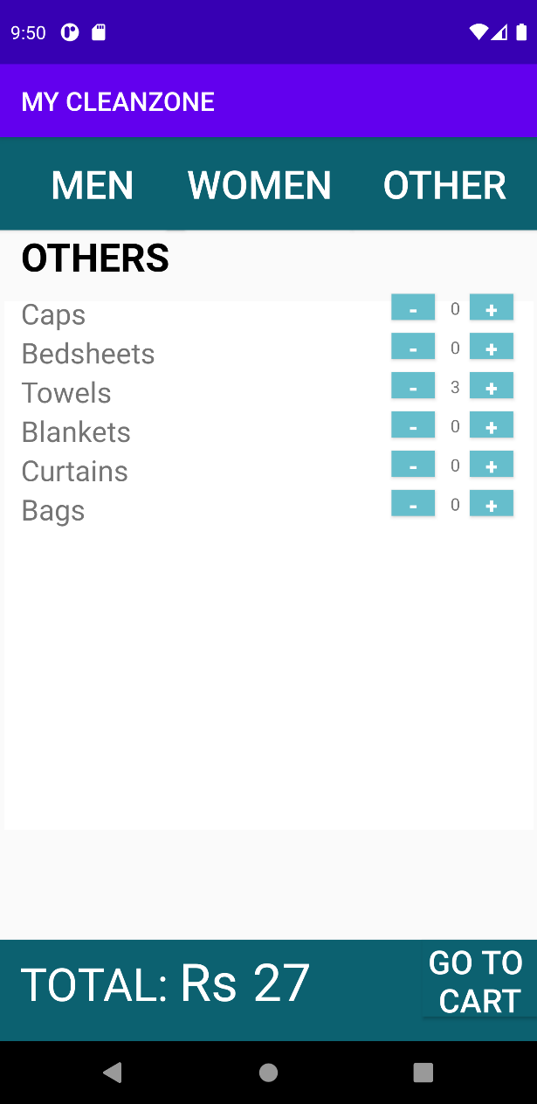

Other.xml

*<?***xml version="1.0" encoding="utf-8"***?>*<**FrameLayout xmlns:android="http://schemas.android.com/apk/res/android"  
 xmlns:tools="http://schemas.android.com/tools"  
 android:layout_width="match_parent"  
 android:layout_height="match_parent"  
 xmlns:app="http://schemas.android.com/apk/res-auto"  
 android:id="@+id/other_frag"  
 tools:context=".other"**>  
  
 *<!--* ***TODO: Update blank fragment layout*** *-->* <**TextView  
 android:layout_marginTop="71dp"  
 android:layout_width="match_parent"  
 android:layout_height="match_parent"  
 android:textStyle="bold"  
 android:layout_marginStart="16dp"  
 android:textColor="@color/black"  
 android:textSize="30dp"  
 android:text="OTHERS"** />  
 <**TextView  
 android:id="@+id/cap"  
 android:layout_width="wrap_content"  
 android:layout_height="wrap_content"  
 android:layout_marginStart="16dp"  
 android:layout_marginTop="120dp"  
 android:layout_marginEnd="176dp"  
 android:text="Caps"  
 android:textSize="22dp"** />  
  
 <**Button  
 android:id="@+id/cap_dec"  
 android:layout_width="33dp"  
 android:layout_height="20dp"  
  
 android:background="@color/blue"  
 android:textColor="@color/white"  
 android:textSize="17dp"  
 android:layout_marginTop="120dp"  
  
 android:layout_marginLeft="300dp"  
 android:text="-"  
 android:textStyle="bold"** />  
  
 <**TextView  
 android:id="@+id/cap_counter"  
 android:layout_width="wrap_content"  
 android:layout_height="wrap_content"  
 android:layout_marginTop="122dp"  
 android:text="0"  
 android:inputType="number"  
  
 android:layout_marginLeft="345dp"  
 android:textSize="13dp"** />  
  
  
 <**Button  
 android:layout_width="33dp"  
 android:layout_height="20dp"  
  
 android:background="@color/blue"  
 android:textColor="@color/white"  
 android:textSize="17dp"  
 android:layout_marginTop="120dp"  
 android:text="+"  
 android:layout_marginLeft="360dp"  
 android:id="@+id/cap_inc"  
 android:textStyle="bold"** />  
 <**TextView  
 android:id="@+id/bedsheet"  
 android:layout_width="wrap_content"  
 android:layout_height="wrap_content"  
 android:layout_marginStart="16dp"  
 android:layout_marginTop="150dp"  
 android:layout_marginEnd="176dp"  
 android:text="Bedsheets"  
 android:textSize="22dp"** />  
  
 <**Button  
 android:id="@+id/bedsheet_dec"  
 android:layout_width="33dp"  
 android:layout_height="20dp"  
  
 android:background="@color/blue"  
 android:textColor="@color/white"  
 android:textSize="17dp"  
 android:layout_marginTop="150dp"  
  
 android:layout_marginLeft="300dp"  
 android:text="-"  
 android:textStyle="bold"** />  
  
 <**TextView  
 android:id="@+id/bedsheet_counter"  
 android:layout_width="wrap_content"  
 android:layout_height="wrap_content"  
 android:layout_marginTop="152dp"  
 android:text="0"  
 android:inputType="number"  
  
 android:layout_marginLeft="345dp"  
 android:textSize="13dp"** />  
  
  
 <**Button  
 android:layout_width="33dp"  
 android:layout_height="20dp"  
  
 android:background="@color/blue"  
 android:textColor="@color/white"  
 android:textSize="17dp"  
 android:layout_marginTop="150dp"  
 android:text="+"  
 android:layout_marginLeft="360dp"  
 android:id="@+id/bedsheet_inc"  
 android:textStyle="bold"** />  
 <**TextView  
 android:id="@+id/towel"  
 android:layout_width="wrap_content"  
 android:layout_height="wrap_content"  
 android:layout_marginStart="16dp"  
 android:layout_marginTop="180dp"  
 android:layout_marginEnd="176dp"  
 android:text="Towels"  
 android:textSize="22dp"** />  
  
 <**Button  
 android:id="@+id/towel_dec"  
 android:layout_width="33dp"  
 android:layout_height="20dp"  
  
 android:background="@color/blue"  
 android:textColor="@color/white"  
 android:textSize="17dp"  
 android:layout_marginTop="180dp"  
  
 android:layout_marginLeft="300dp"  
 android:text="-"  
 android:textStyle="bold"** />  
  
 <**TextView  
 android:id="@+id/towel_counter"  
 android:layout_width="wrap_content"  
 android:layout_height="wrap_content"  
 android:layout_marginTop="182dp"  
 android:text="0"  
 android:inputType="number"  
  
 android:layout_marginLeft="345dp"  
 android:textSize="13dp"** />  
  
  
 <**Button  
 android:layout_width="33dp"  
 android:layout_height="20dp"  
  
 android:background="@color/blue"  
 android:textColor="@color/white"  
 android:textSize="17dp"  
 android:layout_marginTop="180dp"  
 android:text="+"  
 android:layout_marginLeft="360dp"  
 android:id="@+id/towel_inc"  
 android:textStyle="bold"** />  
 <**TextView  
 android:id="@+id/blanket"  
 android:layout_width="wrap_content"  
 android:layout_height="wrap_content"  
 android:layout_marginStart="16dp"  
 android:layout_marginTop="210dp"  
 android:layout_marginEnd="176dp"  
 android:text="Blankets"  
 android:textSize="22dp"** />  
  
 <**Button  
 android:id="@+id/blanket_dec"  
 android:layout_width="33dp"  
 android:layout_height="20dp"  
  
 android:background="@color/blue"  
 android:textColor="@color/white"  
 android:textSize="17dp"  
 android:layout_marginTop="210dp"  
  
 android:layout_marginLeft="300dp"  
 android:text="-"  
 android:textStyle="bold"** />  
  
 <**TextView  
 android:id="@+id/blanket_counter"  
 android:layout_width="wrap_content"  
 android:layout_height="wrap_content"  
 android:layout_marginTop="212dp"  
 android:text="0"  
 android:inputType="number"  
  
 android:layout_marginLeft="345dp"  
 android:textSize="13dp"** />  
  
  
 <**Button  
 android:layout_width="33dp"  
 android:layout_height="20dp"  
  
 android:background="@color/blue"  
 android:textColor="@color/white"  
 android:textSize="17dp"  
 android:layout_marginTop="210dp"  
 android:text="+"  
 android:layout_marginLeft="360dp"  
 android:id="@+id/blanket_inc"  
 android:textStyle="bold"** />  
 <**TextView  
 android:id="@+id/curtain"  
 android:layout_width="wrap_content"  
 android:layout_height="wrap_content"  
 android:layout_marginStart="16dp"  
 android:layout_marginTop="240dp"  
 android:layout_marginEnd="176dp"  
 android:text="Curtains"  
 android:textSize="22dp"** />  
  
 <**Button  
 android:id="@+id/curtain_dec"  
 android:layout_width="33dp"  
 android:layout_height="20dp"  
  
 android:background="@color/blue"  
 android:textColor="@color/white"  
 android:textSize="17dp"  
 android:layout_marginTop="240dp"  
  
 android:layout_marginLeft="300dp"  
 android:text="-"  
 android:textStyle="bold"** />  
  
 <**TextView  
 android:id="@+id/curtain_counter"  
 android:layout_width="wrap_content"  
 android:layout_height="wrap_content"  
 android:layout_marginTop="242dp"  
 android:text="0"  
 android:inputType="number"  
  
 android:layout_marginLeft="345dp"  
 android:textSize="13dp"** />  
  
  
 <**Button  
 android:layout_width="33dp"  
 android:layout_height="20dp"  
  
 android:background="@color/blue"  
 android:textColor="@color/white"  
 android:textSize="17dp"  
 android:layout_marginTop="240dp"  
 android:text="+"  
 android:layout_marginLeft="360dp"  
 android:id="@+id/curtain_inc"  
 android:textStyle="bold"** />  
 <**TextView  
 android:id="@+id/bag"  
 android:layout_width="wrap_content"  
 android:layout_height="wrap_content"  
 android:layout_marginStart="16dp"  
 android:layout_marginTop="270dp"  
 android:layout_marginEnd="176dp"  
 android:text="Bags"  
 android:textSize="22dp"** />  
  
 <**Button  
 android:id="@+id/bag_dec"  
 android:layout_width="33dp"  
 android:layout_height="20dp"  
  
 android:background="@color/blue"  
 android:textColor="@color/white"  
 android:textSize="17dp"  
 android:layout_marginTop="270dp"  
  
 android:layout_marginLeft="300dp"  
 android:text="-"  
 android:textStyle="bold"** />  
  
 <**TextView  
 android:id="@+id/bag_counter"  
 android:layout_width="wrap_content"  
 android:layout_height="wrap_content"  
 android:layout_marginTop="272dp"  
 android:text="0"  
 android:inputType="number"  
  
 android:layout_marginLeft="345dp"  
 android:textSize="13dp"** />  
  
  
 <**Button  
 android:layout_width="33dp"  
 android:layout_height="20dp"  
  
 android:background="@color/blue"  
 android:textColor="@color/white"  
 android:textSize="17dp"  
 android:layout_marginTop="270dp"  
 android:text="+"  
 android:layout_marginLeft="360dp"  
 android:id="@+id/bag_inc"  
 android:textStyle="bold"** />  
  
  
</**FrameLayout**>

Other.java

**package** com.example.mycleanzone;  
  
**import** android.os.Bundle;  
**import** android.support.v4.app.Fragment;  
**import** android.view.LayoutInflater;  
**import** android.view.View;  
**import** android.view.ViewGroup;  
**import** android.widget.Button;  
**import** android.widget.TextView;  
  
*/**  
 * A simple {****@link*** *Fragment} subclass.  
 * Use the {****@link*** *other#newInstance} factory method to  
 * create an instance of this fragment.  
 */***public class** other **extends** Fragment {  
  
 *//* ***TODO: Rename parameter arguments, choose names that match*** *// the fragment initialization parameters, e.g. ARG_ITEM_NUMBER* **private static final** String ***ARG_PARAM1*** = **"param1"**;  
 **private static final** String ***ARG_PARAM2*** = **"param2"**;  
  
 *//* ***TODO: Rename and change types of parameters* private** String **mParam1**;  
 **private** String **mParam2**;  
  
 **public** other() {  
 *// Required empty public constructor* }  
  
 */**  
 * Use this factory method to create a new instance of  
 * this fragment using the provided parameters.  
 *  
 \** ***@param param1*** *Parameter 1.  
 \** ***@param param2*** *Parameter 2.  
 \** ***@return*** *A new instance of fragment other.  
 */  
 //* ***TODO: Rename and change types and number of parameters* public static** other newInstance(String param1, String param2) {  
 other fragment = **new** other();  
 Bundle args = **new** Bundle();  
 args.putString(***ARG_PARAM1***, param1);  
 args.putString(***ARG_PARAM2***, param2);  
 fragment.setArguments(args);  
 **return** fragment;  
 }  
 Button **cap_inc**, **bedsheet_inc**, **towel_inc**, **blanket_inc**,**curtain_inc**,**bag_inc**;  
 Button **cap_dec**, **bedsheet_dec**, **towel_dec**, **blanket_dec**,**curtain_dec**,**bag_dec**;  
 TextView **cap_count**, **bedsheet_count**, **towel_count**, **blanket_count**,**curtain_count**,**bag_count**;  
  
  
 **public static int** *other_tot*=0;  
 **public static int** *other_qt*=0;  
  
 @Override  
 **public void** onCreate(Bundle savedInstanceState) {  
 **super**.onCreate(savedInstanceState);  
 **if** (getArguments() != **null**) {  
 **mParam1** = getArguments().getString(***ARG_PARAM1***);  
 **mParam2** = getArguments().getString(***ARG_PARAM2***);  
 }  
 }  
  
 @Override  
 **public** View onCreateView(LayoutInflater inflater, ViewGroup container,  
 Bundle savedInstanceState) {  
 *// Inflate the layout for this fragment* View v= inflater.inflate(R.layout.***fragment_other***, container, **false**);  
  
  
 **cap_inc** = (Button) v.findViewById(R.id.***cap_inc***);  
 **cap_dec** = (Button) v.findViewById(R.id.***cap_dec***);  
 **cap_count** = (TextView) v.findViewById(R.id.***cap_counter***);  
 **cap_inc**.setOnClickListener(**new** other.cap_inc());  
 **cap_dec**.setOnClickListener(**new** other.cap_dec());  
 **bedsheet_inc** = (Button) v.findViewById(R.id.***bedsheet_inc***);  
 **bedsheet_dec** = (Button) v.findViewById(R.id.***bedsheet_dec***);  
 **bedsheet_count** = (TextView) v.findViewById(R.id.***bedsheet_counter***);  
 **bedsheet_inc**.setOnClickListener(**new** other.bedsheet_inc());  
 **bedsheet_dec**.setOnClickListener(**new** other.bedsheet_dec());  
 **towel_inc** = (Button) v.findViewById(R.id.***towel_inc***);  
 **towel_dec** = (Button) v.findViewById(R.id.***towel_dec***);  
 **towel_count** = (TextView) v.findViewById(R.id.***towel_counter***);  
 **towel_inc**.setOnClickListener(**new** other.towel_inc());  
 **towel_dec**.setOnClickListener(**new** other.towel_dec());  
 **blanket_inc** = (Button) v.findViewById(R.id.***blanket_inc***);  
 **blanket_dec** = (Button) v.findViewById(R.id.***blanket_dec***);  
 **blanket_count** = (TextView) v.findViewById(R.id.***blanket_counter***);  
 **blanket_inc**.setOnClickListener(**new** other.blanket_inc());  
 **blanket_dec**.setOnClickListener(**new** other.blanket_dec());  
 **curtain_inc** = (Button) v.findViewById(R.id.***curtain_inc***);  
 **curtain_dec** = (Button) v.findViewById(R.id.***curtain_dec***);  
 **curtain_count** = (TextView) v.findViewById(R.id.***curtain_counter***);  
 **curtain_inc**.setOnClickListener(**new** other.curtain_inc());  
 **curtain_dec**.setOnClickListener(**new** other.curtain_dec());  
 **bag_inc** = (Button) v.findViewById(R.id.***bag_inc***);  
 **bag_dec** = (Button) v.findViewById(R.id.***bag_dec***);  
 **bag_count** = (TextView) v.findViewById(R.id.***bag_counter***);  
 **bag_inc**.setOnClickListener(**new** other.bag_inc());  
 **bag_dec**.setOnClickListener(**new** other.bag_dec());  
  
 **return** v;  
 }  
  
 **void** total() {  
 **int** cap_amt = Integer.*parseInt*(**cap_count**.getText().toString()) ;  
 **int** bedsheet_amt = Integer.*parseInt*(**bedsheet_count**.getText().toString()) ;  
 **int** towel_amt = Integer.*parseInt*(**towel_count**.getText().toString()) ;  
 **int** blanket_amt = Integer.*parseInt*(**blanket_count**.getText().toString()) ;  
 **int** curtain_amt=Integer.*parseInt*(**curtain_count**.getText().toString()) ;  
 **int** bag_amt=Integer.*parseInt*(**bag_count**.getText().toString()) ;  
 **if**(Category.*choice*==1){  
 *other_tot* = cap_amt*8 + bedsheet_amt*19 + towel_amt*16 + blanket_amt*80+curtain_amt*10+bag_amt*10;  
 wash_iron.*amt*.setText(Integer.*toString*(*other_tot*));}  
 **else if**(Category.*choice*==2){  
 *other_tot* = cap_amt*3 + bedsheet_amt*9 + towel_amt*9 + blanket_amt*30+curtain_amt*5;  
 iron.*amt*.setText(Integer.*toString*(*other_tot*));}  
 **else if**(Category.*choice*==3)  
 { *other_tot* = cap_amt*15 + bedsheet_amt*40 + towel_amt*30 + blanket_amt*150+curtain_amt*25;  
 dry_clean.*amt*.setText(Integer.*toString*(*other_tot*));  
  
 }  
 *other_qt* = cap_amt + bedsheet_amt + towel_amt + blanket_amt+curtain_amt;  
  
  
  
 }  
  
 **void** increment(TextView tv) {  
 String s = tv.getText().toString();  
 **int** ss = Integer.*parseInt*(s);  
 ss++;  
 String sss = Integer.*toString*(ss);  
 tv.setText(sss);  
 total();  
 }  
  
 **void** decrement(TextView tv) {  
 String s = tv.getText().toString();  
 **int** ss = Integer.*parseInt*(s);  
 **if** (ss > 0)  
 ss--;  
 **else** ss = 0;  
 String sss = Integer.*toString*(ss);  
 tv.setText(sss);  
 total();  
 }  
  
 **class** cap_inc **implements** View.OnClickListener {  
 @Override  
 **public void** onClick(View v) {  
 increment(**cap_count**);  
 }  
 }  
  
 **class** cap_dec **implements** View.OnClickListener {  
 @Override  
 **public void** onClick(View v) {  
 decrement(**cap_count**);  
  
 }  
  
 }  
  
 **class** bedsheet_inc **implements** View.OnClickListener {  
 @Override  
 **public void** onClick(View v) {  
 increment(**bedsheet_count**);  
 }  
 }  
  
 **class** bedsheet_dec **implements** View.OnClickListener {  
 @Override  
 **public void** onClick(View v) {  
 decrement(**bedsheet_count**);  
 }  
  
 }  
  
 **class** towel_inc **implements** View.OnClickListener {  
 @Override  
 **public void** onClick(View v) {  
 increment(**towel_count**);  
 }  
 }  
  
 **class** towel_dec **implements** View.OnClickListener {  
 @Override  
 **public void** onClick(View v) {  
 decrement(**towel_count**);  
 }  
  
 }  
  
 **class** curtain_inc **implements** View.OnClickListener {  
 @Override  
 **public void** onClick(View v) {  
 increment(**curtain_count**);  
 }  
 }  
  
 **class** curtain_dec **implements** View.OnClickListener {  
 @Override  
 **public void** onClick(View v) {  
 decrement(**curtain_count**);  
 }  
  
 }  
 **class** blanket_inc **implements** View.OnClickListener {  
 @Override  
 **public void** onClick(View v) {  
 increment(**blanket_count**);  
 }  
 }  
  
 **class** blanket_dec **implements** View.OnClickListener {  
 @Override  
 **public void** onClick(View v) {  
 decrement(**blanket_count**);  
  
 }  
  
 }  
 **class** bag_inc **implements** View.OnClickListener {  
 @Override  
 **public void** onClick(View v) {  
 increment(**bag_count**);  
 }  
 }  
  
 **class** bag_dec **implements** View.OnClickListener {  
 @Override  
 **public void** onClick(View v) {  
 decrement(**bag_count**);  
  
 }  
  
 }  
  
  
}

**Payment:**

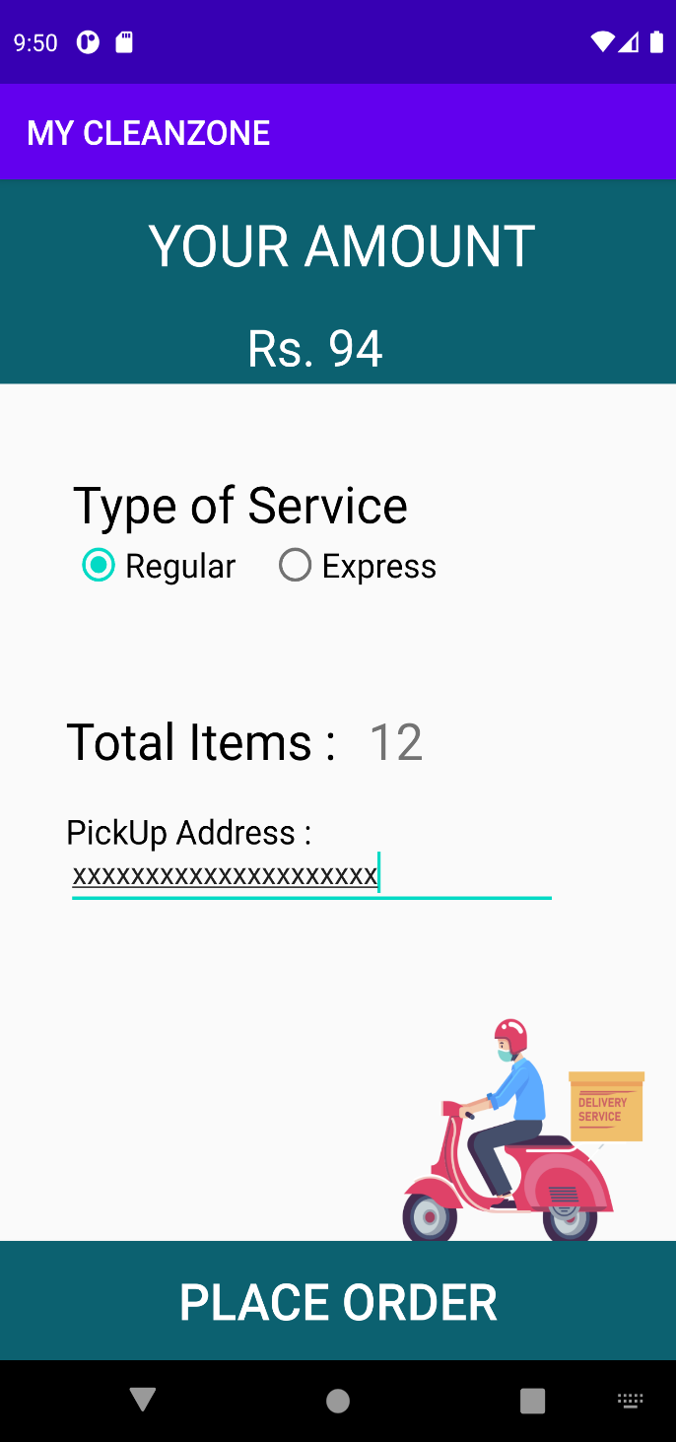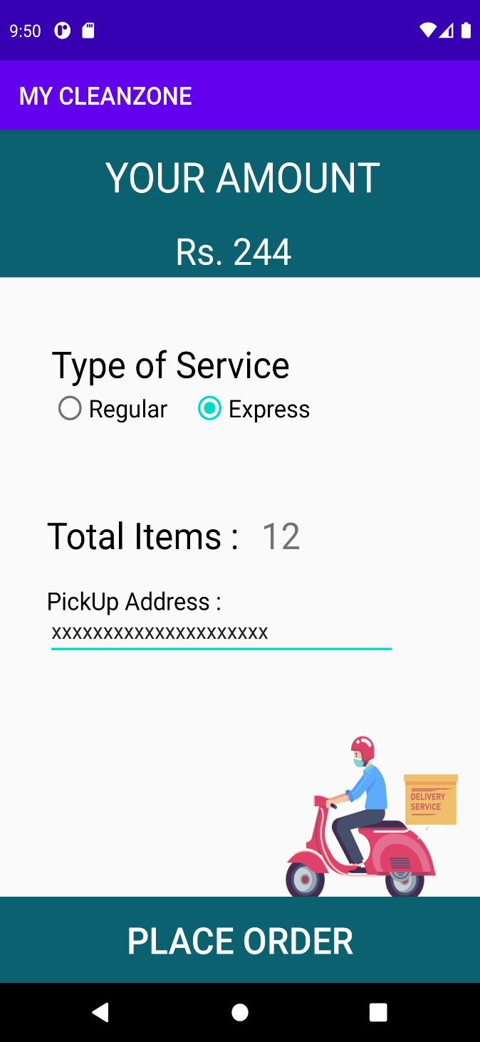

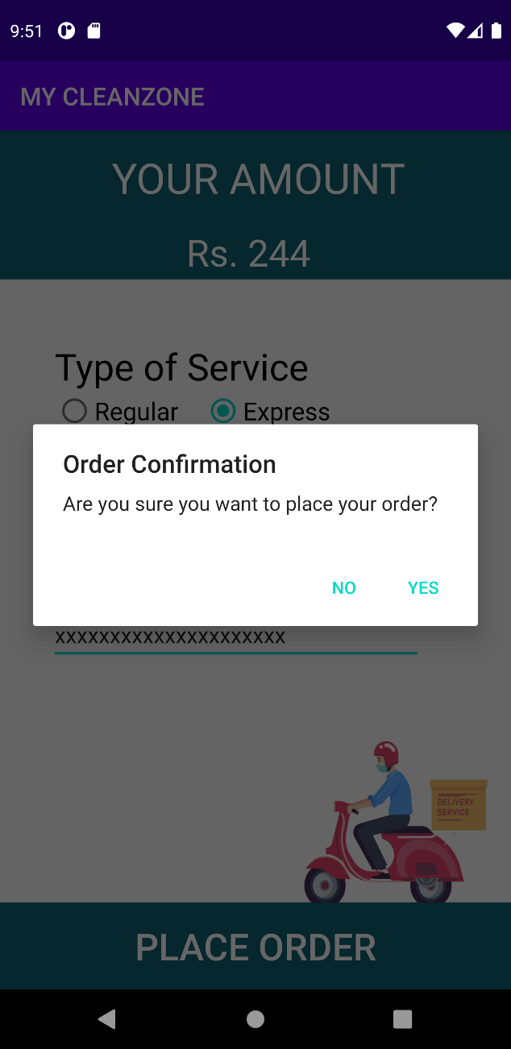

Payment.xml

*<?***xml version="1.0" encoding="utf-8"***?>*<**android.support.constraint.ConstraintLayout xmlns:android="http://schemas.android.com/apk/res/android"  
 xmlns:app="http://schemas.android.com/apk/res-auto"  
 xmlns:tools="http://schemas.android.com/tools"  
 android:layout_width="match_parent"  
 android:layout_height="match_parent"  
 tools:context=".payment"**>  
  
 <**TextView  
 android:id="@+id/textView2"  
 android:layout_width="448dp"  
 android:layout_height="120dp"  
  
 android:layout_marginBottom="124dp"  
 android:background="@color/midnight_blue"  
 android:paddingLeft="90dp"  
 android:paddingTop="15dp"  
 android:text="YOUR AMOUNT"  
 android:textColor="@color/white"  
 android:textSize="34dp"  
 app:layout_constraintBottom_toTopOf="@+id/service"  
 app:layout_constraintStart_toStartOf="parent"  
 app:layout_constraintTop_toTopOf="parent"  
 app:layout_constraintVertical_bias="0.284"** />  
  
 <**TextView  
 android:id="@+id/textView"  
 android:layout_width="wrap_content"  
 android:layout_height="wrap_content"  
 android:layout_marginTop="78dp"  
 android:layout_marginBottom="559dp"  
 android:background="@color/midnight_blue"  
 android:textColor="@color/white"  
 android:textSize="30dp"  
 android:layout_marginLeft="150dp"  
  
 app:layout_constraintStart_toStartOf="parent"  
 app:layout_constraintTop_toTopOf="parent"** />  
  
 <**TextView  
 android:id="@+id/service"  
 android:layout_width="wrap_content"  
 android:layout_height="wrap_content"  
 android:layout_marginStart="44dp"  
 android:layout_marginBottom="10dp"  
 android:text="Type of Service"  
 android:textColor="@color/black"  
 android:textSize="30dp"  
 android:layout_marginTop="50dp"  
  
 app:layout_constraintStart_toStartOf="parent"  
 app:layout_constraintTop_toBottomOf="@+id/textView2"** />  
  
 <**RadioGroup  
 android:id="@+id/radioGroup"  
 android:layout_width="261dp"  
 android:layout_height="64dp"  
  
 android:layout_marginBottom="34dp"  
 android:orientation="horizontal"  
  
 app:layout_constraintStart_toStartOf="@+id/service"  
 app:layout_constraintTop_toBottomOf="@+id/service"**>  
  
  
 <**RadioButton  
 android:id="@+id/regular"  
 android:layout_width="wrap_content"  
 android:layout_height="wrap_content"  
 android:layout_marginLeft="0dp"  
 android:checked="true"  
 android:text="Regular"  
 android:textSize="20dp"** />  
  
 <**RadioButton  
 android:id="@+id/express"  
 android:layout_width="wrap_content"  
 android:layout_height="wrap_content"  
 android:layout_marginLeft="20dp"  
 android:checked="false"  
 android:text="Express"  
 android:textSize="20dp"** />  
 </**RadioGroup**>  
  
 <**TextView  
 android:id="@+id/items"  
 android:layout_width="wrap_content"  
 android:layout_height="wrap_content"  
 android:layout_marginStart="40dp"  
 android:layout_marginEnd="19dp"  
 android:layout_marginBottom="56dp"  
 android:text="Total Items :"  
 android:textColor="@color/black"  
 android:textSize="30dp"  
 app:layout_constraintBottom_toTopOf="@+id/textView17"  
 app:layout_constraintEnd_toStartOf="@+id/quantity"  
 app:layout_constraintStart_toStartOf="parent"  
 app:layout_constraintTop_toBottomOf="@+id/radioGroup"** />  
  
 <**TextView  
 android:id="@+id/quantity"  
 android:layout_width="0dp"  
 android:layout_height="wrap_content"  
 android:layout_marginEnd="97dp"  
 android:textSize="30dp"  
 app:layout_constraintBaseline_toBaselineOf="@+id/items"  
 app:layout_constraintEnd_toEndOf="parent"  
 app:layout_constraintStart_toEndOf="@+id/items"** />  
  
 <**Button  
 android:id="@+id/place"  
 android:layout_width="match_parent"  
 android:layout_height="70dp"  
  
 android:background="@color/midnight_blue"  
 android:text="PLACE ORDER"  
 android:textColor="@color/white"  
 android:textSize="30dp"  
 app:layout_constraintBottom_toBottomOf="parent"  
 app:layout_constraintEnd_toEndOf="parent"  
 app:layout_constraintStart_toStartOf="parent"  
 app:layout_constraintTop_toBottomOf="@+id/editText"** />  
  
 <**TextView  
 android:id="@+id/textView16"  
 android:layout_width="wrap_content"  
 android:layout_height="wrap_content"  
 android:text="PickUp Address :"  
 android:textColor="@color/black"  
 android:textSize="20dp"  
 app:layout_constraintTop_toBottomOf="@+id/items"  
 app:layout_constraintStart_toStartOf="@+id/items"  
 android:layout_marginTop="20dp"**/>  
  
 <**EditText  
 android:id="@+id/editText"  
 android:layout_width="300dp"  
 android:layout_height="wrap_content"  
 android:layout_marginTop="20dp"  
 android:layout_marginBottom="193dp"  
 android:hint="Enter your address"  
 app:layout_constraintBottom_toTopOf="@+id/place"  
 app:layout_constraintEnd_toEndOf="parent"  
 app:layout_constraintHorizontal_bias="0.0"  
 app:layout_constraintStart_toStartOf="@id/textView16"  
 app:layout_constraintTop_toBottomOf="@+id/textView16"** />  
  
 <**TextView  
 android:id="@+id/textView17"  
 android:layout_width="392dp"  
 android:layout_height="240dp"  
 android:layout_marginStart="116dp"  
 android:background="@drawable/order"  
  
 app:layout_constraintBottom_toBottomOf="@+id/place"  
 app:layout_constraintStart_toStartOf="parent"  
 android:layout_marginBottom="13dp"**/>  
</**android.support.constraint.ConstraintLayout**>

Payment.java

**package** com.example.mycleanzone;  
  
**import** android.app.AlertDialog;  
**import** android.content.Context;  
**import** android.content.DialogInterface;  
**import** android.content.Intent;  
**import** android.support.v7.app.AppCompatActivity;  
**import** android.os.Bundle;  
**import** android.view.View;  
**import** android.widget.Button;  
**import** android.widget.RadioButton;  
**import** android.widget.RadioGroup;  
**import** android.widget.TextView;  
  
**public class** payment **extends** AppCompatActivity {  
 TextView **t1**, **qt**;  
 RadioGroup **rg**;  
 Context **myContext** = **null**;  
 AlertDialog.Builder **adb** = **null**;  
 AlertDialog **ad** = **null**;  
 RadioButton **reg**, **exp**;  
 Button **place**;  
  
 @Override  
 **protected void** onCreate(Bundle savedInstanceState) {  
 **super**.onCreate(savedInstanceState);  
 setContentView(R.layout.***activity_payment***);  
 wash_iron wi = **new** wash_iron();  
 **qt** = (TextView) findViewById(R.id.***quantity***);  
 **t1** = (TextView) findViewById(R.id.***textView***);  
 Intent i = getIntent();  
 **myContext** = **this**.getApplicationContext();  
 **place** = (Button) findViewById(R.id.***place***);  
 **rg** = (RadioGroup) findViewById(R.id.***radioGroup***);  
 **reg** = (RadioButton) findViewById(R.id.***regular***);  
 **exp** = (RadioButton) findViewById(R.id.***express***);  
 men ob = **new** men();  
 women ob2 = **new** women();  
 other ob3 = **new** other();  
 String data=Integer.*toString*((ob.*men_qt* + ob2.*women_qt* + ob3.*other_qt*));  
 **qt**.setText(Integer.*toString*((ob.*men_qt* + ob2.*women_qt* + ob3.*other_qt*)));  
 String s = i.getStringExtra(**"data"**);  
 **t1**.setText(**"Rs. "** + (ob.*men_tot* + ob2.*women_tot* + ob3.*other_tot*));  
 **rg**.setOnCheckedChangeListener(**new** RadioGroup.OnCheckedChangeListener() {  
  
 @Override  
 **public void** onCheckedChanged(RadioGroup group, **int** checkedId) {  
  
 **if** (checkedId == R.id.***regular***) {  
 **t1**.setText(**"Rs. "** + (ob.*men_tot* + ob2.*women_tot* + ob3.*other_tot*));  
 } **else if** (checkedId == R.id.***express***) {  
 **t1**.setText(**"Rs. "** + (ob.*men_tot* + ob2.*women_tot* + ob3.*other_tot* + 150));  
 }  
 }  
 });  
  
  
 **adb** = **new** AlertDialog.Builder(**this**);  
 **adb**.setCancelable(**false**);  
 **adb**.setMessage(**"Are you sure you want to place your order?"**);  
 **adb**.setPositiveButton(**"YES"**, **new** DialogInterface.OnClickListener() {  
 @Override  
 **public void** onClick(DialogInterface dialog, **int** id) {  
  
 Intent intent=**new** Intent(getApplicationContext(),Final_order.**class**);  
 intent.putExtra(**"data"**,data);  
 startActivity(intent);  
 }  
  
 });  
 **adb**.setNegativeButton(**"NO"**, **new** DialogInterface.OnClickListener() {  
 @Override  
 **public void** onClick(DialogInterface dialog, **int** which) {  
  
 }  
 });  
 **ad** = **adb**.create();  
 **ad**.setTitle(**"Order Confirmation"**);  
 **place**.setOnClickListener(**new** View.OnClickListener() {  
 @Override  
 **public void** onClick(View v) {  
 **ad**.show();  
 }  
 });  
 }  
}

**Final order:**

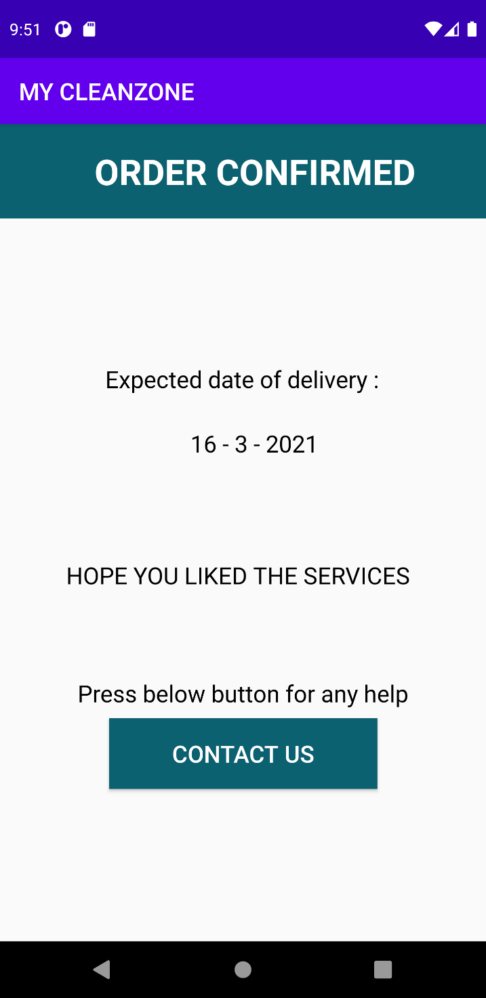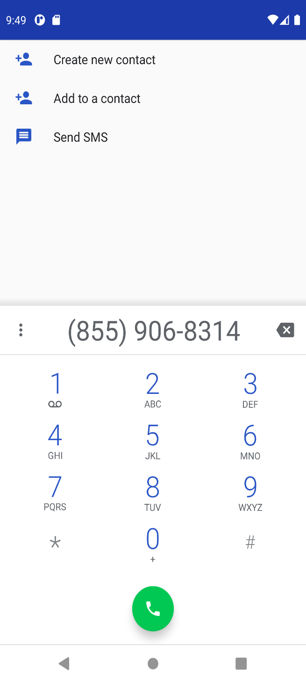

Final_order.xml

*<?***xml version="1.0" encoding="utf-8"***?>*<**android.support.constraint.ConstraintLayout xmlns:android="http://schemas.android.com/apk/res/android"  
 xmlns:app="http://schemas.android.com/apk/res-auto"  
 xmlns:tools="http://schemas.android.com/tools"  
 android:layout_width="match_parent"  
 android:layout_height="match_parent"  
 tools:context=".Final_order"**>  
  
  
 <**TextView  
 android:id="@+id/textView3"  
 android:layout_width="match_parent"  
 android:layout_height="80dp"  
 android:layout_marginBottom="177dp"  
 android:background="@color/midnight_blue"  
 android:paddingLeft="80dp"  
 android:paddingTop="20dp"  
 android:text="ORDER CONFIRMED"  
 android:textColor="@color/white"  
 android:textSize="30dp"  
 android:textStyle="bold"  
 app:layout_constraintBottom_toTopOf="@+id/textView5"  
 app:layout_constraintEnd_toEndOf="parent"  
 app:layout_constraintStart_toStartOf="parent"  
 app:layout_constraintTop_toTopOf="parent"** />  
  
  
  
  
 <**TextView  
 android:id="@+id/textView4"  
 android:layout_width="wrap_content"  
 android:layout_height="57dp"  
 android:layout_marginStart="32dp"  
 android:layout_marginEnd="32dp"  
 android:layout_marginBottom="24dp"  
 android:text="Expected date of delivery :"  
 android:textColor="@color/black"  
 android:textSize="20dp"  
 app:layout_constraintBottom_toBottomOf="@+id/textView5"  
 app:layout_constraintEnd_toEndOf="parent"  
 app:layout_constraintHorizontal_bias="0.495"  
 app:layout_constraintStart_toStartOf="parent"** />  
  
  
  
  
 <**TextView  
 android:id="@+id/textView5"  
 android:layout_width="wrap_content"  
 android:layout_height="wrap_content"  
 android:layout_marginStart="72dp"  
 android:layout_marginBottom="85dp"  
 android:textColor="@color/black"  
 android:textSize="20dp"  
 app:layout_constraintBottom_toTopOf="@+id/textView7"  
 app:layout_constraintStart_toStartOf="@+id/textView4"  
 app:layout_constraintTop_toBottomOf="@+id/textView3"** />  
  
 <**TextView  
 android:id="@+id/textView6"  
 android:layout_width="wrap_content"  
 android:layout_height="wrap_content"  
 android:layout_marginBottom="8dp"  
 android:text="Press below button for any help"  
 android:textColor="@color/black"  
 android:textSize="20dp"  
 app:layout_constraintBottom_toTopOf="@+id/button"  
 app:layout_constraintEnd_toEndOf="parent"  
 app:layout_constraintStart_toStartOf="parent"  
 app:layout_constraintTop_toBottomOf="@+id/textView7"** />  
  
 <**TextView  
 android:id="@+id/textView7"  
 android:layout_width="wrap_content"  
 android:layout_height="0dp"  
 android:layout_marginStart="56dp"  
 android:layout_marginBottom="71dp"  
 android:text="HOPE YOU LIKED THE SERVICES"  
 android:textColor="@color/black"  
 android:textSize="20dp"  
 app:layout_constraintBottom_toTopOf="@+id/textView6"  
 app:layout_constraintStart_toStartOf="parent"  
 app:layout_constraintTop_toBottomOf="@+id/textView5"** />  
 <**Button  
  
 android:id="@+id/button"  
 android:layout_width="227dp"  
 android:layout_height="60dp"  
 android:layout_marginBottom="129dp"  
 android:background="@color/midnight_blue"  
 android:onClick="dial"  
 android:text="CONTACT US"  
 android:textColor="@color/white"  
 android:textSize="20dp"  
  
 app:layout_constraintBottom_toBottomOf="parent"  
 app:layout_constraintEnd_toEndOf="parent"  
 app:layout_constraintStart_toStartOf="parent"  
 app:layout_constraintTop_toBottomOf="@+id/textView6"**/>  
  
  
  
</**android.support.constraint.ConstraintLayout**>

Final_order.java

**package** com.example.mycleanzone;  
  
**import** android.content.Intent;  
**import** android.net.Uri;  
**import** android.support.v7.app.AppCompatActivity;  
**import** android.os.Bundle;  
**import** android.view.View;  
**import** android.widget.TextView;  
  
**import** java.text.SimpleDateFormat;  
**import** java.util.Calendar;  
**import** java.util.Date;  
  
**public class** Final_order **extends** AppCompatActivity {  
TextView **date_txt**;  
 @Override  
 **protected void** onCreate(Bundle savedInstanceState) {  
 **super**.onCreate(savedInstanceState);  
 setContentView(R.layout.***activity_final_order***);  
 Intent intent=getIntent();  
  
 Calendar c=Calendar.*getInstance*();  
 **int** date=c.get(Calendar.***DATE***);  
 **int** month=c.get(Calendar.***MONTH***);  
 **int** year=c.get(Calendar.***YEAR***);  
 **date_txt**=(TextView)findViewById(R.id.***textView5***);  
 String data;  
 data=intent.getStringExtra(**"data"**);  
  
  
 **if**(Integer.*parseInt*(data)<10)  
 c.add(Calendar.***DATE***,2);  
 **else if**(Integer.*parseInt*(data)<25)  
 c.add(Calendar.***DATE***,4);  
 **else** c.add(Calendar.***DATE***,8);  
 **date_txt**.setText((Integer.*toString*(c.get(Calendar.***DATE***)))+**" - "**+(Integer.*toString*(c.get(Calendar.***MONTH***)))+**" - "**+(Integer.*toString*(c.get(Calendar.***YEAR***))));  
  
  
 }  
 **public void** dial(View vv) {  
 String number=**"8559068314"**;  
 Intent it = **new** Intent(Intent.***ACTION_DIAL***);  
 it.setData(Uri.*parse*(**"tel:"** +number));  
 startActivity(it);  
 }  
}